**‘Love stronger than death’**

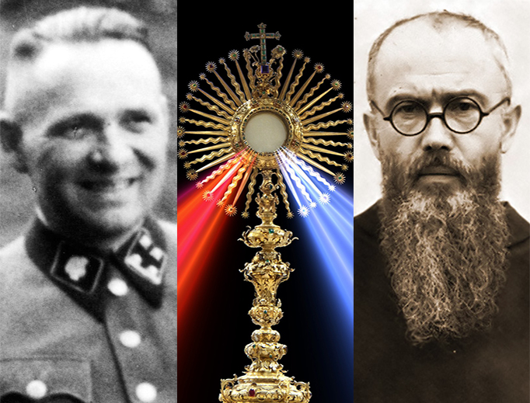

**by**

**Damien F. Mackey**

*“How God will judge my life I know not, but I trust he will see me with mercy and compassion. I am only certain there will be three surprises in Heaven. First of all, I will see some people whom I never expected to see. Second, there will be a number whom I expected who will not be there. And – even relying on God’s mercy – the biggest surprise of all may be that I will be there. When the record of any human life is set down, there are three pairs of eyes who see it in a different light. 1. As I see it. 2. As others see it. 3. As God sees it.”*

***Archbishop Fulton J. Sheen***

The Holy Spirit is a God of surprises.

One has only to consider his most surprising words to the prophet Elijah, who had recently foretold the terrible death of king Ahab of Israel (I Kings 21:19), saying to the prophet (v. 29): ‘Do you see how my servant Ahab has humbled himself before me? Because he has done this, I will not do what I promised during his lifetime’.

That, to me, comes as a great surprise.

His mercy is boundless. He wants us to be saved more than we do.

Now consider his shocking command to St. Peter (Acts 10:9-16):

About noon the following day as they were on their journey and approaching the city, Peter went up on the roof to pray. He became hungry and wanted something to eat, and while the meal was being prepared, he fell into a trance. He saw heaven opened and something like a large sheet being let down to earth by its four corners. It contained all kinds of four-footed animals, as well as reptiles and birds. Then a voice told him, ‘Get up, Peter. Kill and eat’.

**‘**Surely not, Lord!’ Peter replied. ‘I have never eaten anything impure or unclean’.

The voice spoke to him a second time, ‘Do not call anything impure that God has made clean’.

This happened three times, and immediately the sheet was taken back to heaven.

Cf. Ezekiel 4:12-15.

Now here follows another shocker.

An Astonishing Miracle of Divine Mercy at Auschwitz

“Proclaim that mercy is the greatest attribute of God.”

[K.V. Turley](https://www.ncregister.com/blog/kturley)

I have visited Auschwitz only once.  
It is not a place to which I wish to return any time soon.  
Although that visit was many years ago, Auschwitz is a place one does not forget.  
Whether it is the large silent rooms with glass screens, behind which lie the stacked remains of the confiscated clothes and luggage, spectacles and identity cards or (worse still) the extracted teeth or hair from the inmates of that concentration camp; or, the still-lingering smell of gas around the chimneys of the camp incinerator; or the fact that what is said about birdsong not being heard at Auschwitz is true — whatever it is, Auschwitz is not an easy place to forget. Like a bad dream it lingers in one’s waking memory. Only this was a nightmare all too real for those unfortunate enough to be incarcerated within its razor-wire fences.  
  
St. Maximilian Kolbe

One such inmate was the Polish priest, now martyr-saint, Maximilian Kolbe. He arrived in Auschwitz May 28, 1941. No longer a man with a name, he had become instead Prisoner No. 16670.  
Two months later, Kolbe offered his life to save another prisoner who was previously unknown to the priest but who had been sentenced to death by starvation. Kolbe’s offer was accepted. He was consigned to the starvation bunker in the basement of Block 11, known as the “Death Block.” Eventually, Kolbe died Aug. 14, 1941, after having been given a lethal injection.  
Having visited the block where the saint had given his life, it was time to leave Auschwitz. In fact, if truth be known, I couldn’t get away quick enough from the place.

The Fall of Rudolf Höss

Years later I heard an unexpected story about Auschwitz. Yet, perhaps, it is not so unexpected after all. In that camp where so much evil abounded, there, too, grace was to be found.  
Rudolf Höss, the former commandant of Auschwitz, was born into a devout German Catholic family. World War One followed an unhappy childhood. Aged just 17 years, Höss served in the German Imperial Army as a noncommissioned officer. In the national chaos that followed his country’s defeat, Höss returned home. Soon he was involved with right-wing paramilitary groups.  
It was in Munich in March 1922 that his life was changed forever. For it was then that he heard the voice of a “prophet,” calling him once more to the cause of the Fatherland. It was a decisive moment for the future commandant of Auschwitz, as the voice that transfixed him was that of Adolf Hitler.  
It was also the moment when the 21-year-old Höss renounced his Catholic faith.  
From that moment on Höss’ path was clear. There followed his involvement in a Nazi-inspired murder — then imprisonment, before his eventual release in 1928 as part of a general amnesty for prisoners. Thereafter, he became acquainted with the head of the SS, Heinrich Himmler. And soon Höss was party to Hitler’s extermination camps. Another World War brought the eventual destruction of the Fatherland. A botched escape attempt from the advancing Allies brought Höss to a court at Nuremberg to face charges of perpetrating war crimes.  
“I commanded Auschwitz until 1 December 1943, and estimate that at least 2,500,000 victims were executed and exterminated there by gassing and burning, and at least another half-million succumbed to starvation and disease, making a total of about 3,000,000 dead,” Höss admitted to his captors.  
The verdict was never in doubt. Neither was the penalty: In that same courtroom, the 45-year-old Höss was sentenced to death by hanging.  
  
The Salvation of Rudolf Höss

The day after the verdict, former inmates of Auschwitz petitioned the court that Höss’ execution take place on the grounds of the former death camp. German POWs were instructed to erect a gallows there.  
Somewhere, buried under the debris of his years worshipping a false prophet, there remained the fact of his baptism, his Catholic upbringing and, some say, his early desire to be a priest. Whether it was the residue of these things or simply fear, Höss, knowing he was about to die, asked to see a priest.  
His captors struggled to find one. Desperate, Höss remembered a name: Father Władysław Lohn. This Polish Jesuit was the sole survivor of a Jesuit community that had perished in Auschwitz years earlier. The Gestapo had arrested the Krakow Jesuits and sent them to Auschwitz. Jesuit superior Fr. Lohn, on discovering what had happened, went to the camp. He was brought before the Commandant. The priest, who was subsequently allowed to depart unharmed, had impressed Höss. Now that his execution approached Höss asked his captors to find the priest.  
It was April 4, 1947 — Good Friday.  
In the end, and just in time, they found him. On April 10, 1947, Fr. Lohn heard Höss’ confession, and the next day, the Friday of Easter Week, the condemned man received Holy Communion.  
The following day the prisoner wrote to his wife:

“Based on my present knowledge, I can see today clearly, severely and bitterly for me, that the entire ideology about the world in which I believed so firmly and unswervingly was based on completely wrong premises. … And so my actions in the service of this ideology were completely wrong. … My turning away from my belief in God was based on completely wrong premises. It was a hard struggle. But I have again found my faith in my God.”  
  
The Last Execution in Block 11

On the morning of April 16, 1947, military guards stood around Auschwitz as Höss arrived. He was taken to the building that had once been the commandant’s office. There, he asked for and was given a cup of coffee. Having drunk it, he was led to a cell in Block 11 — the “Death Block” — the same block in which St. Maximilian Kolbe had died. Here Höss was to wait.  
Two hours later he was led from Block 11. His captors noticed how calm the handcuffed prisoner was as he walked briskly through the camp to the waiting gallows. The executioners had to help Höss climb onto the stool placed above the gallows trapdoor.  
The sentence was read out as the hangman placed a noose around the neck of the condemned man who, at this site, had ordered the death of so many others. Then, as a silence fell, the hangman stood back, and removed the stool.  
After his death, a letter written by Höss was published in Polish newspapers. It read thus:  
“In the solitude of my prison cell, I have come to the bitter recognition . . . I caused unspeakable suffering … but the Lord God forgave me.”  
  
God’s Greatest Attribute

In 1934 Höss had joined SS-Totenkopfverbände. These were the SS Death Head’s Units, tasked with the administration of Nazi concentration camps. Later that year, in his new designation, he took up his first posting at Dachau.  
In 1934 Sister, later Saint, Faustina Kowalska started to keep a diary detailing the revelations she was experiencing of what later would become the devotion known as the Divine Mercy.  
In her diary these words are attributed to Our Lord: “Proclaim that mercy is the greatest attribute of God.”  
When in April 1947 Höss’ captors went to look for Fr. Lohn, they found him in nearby Krakow.  
He was praying at the Shrine of Divine Mercy.

This article originally appeared Aug. 14, 2019, at the Register.

**By Marc Massery**

This Jan. 27 marks the 75th anniversary of the liberation of the Nazi concentration camp of Auschwitz. With that in mind, we have a powerful story to share.

Though the infamous commandant of the Auschwitz concentration camp, Rudolf Höss, oversaw the murder of millions of innocent people during World War II, in the end, even his horrific sins weren’t bigger than the mercy of God.

Höss was born in 1900 in Baden-Baden, Germany, to strict Catholic parents. His father wanted him to become a priest, but after his father’s death, Rudolf decided to join the German military instead.

**‘The Final Solution’**

In the early 1920s, after hearing Adolf Hitler speak in Munich, Germany, Höss renounced his Catholic faith and became one of the earliest members of the Nazi Party. First, he served a few years at the Dachau concentration camp. Having proved himself, in 1940 he was named the first commandant of Auschwitz, which he converted into what would become one of the largest death camps in world history. SS leader Heinrich Himmler put Höss in charge of carrying out in Auschwitz the “Final Solution,” the complete extermination of all Jews in Europe.

Though Höss denied ever killing anyone by his own hand, he was responsible for streamlining the execution process by introducing the lethal poison Zyklon B, which enabled the murder of as many as 2,000 people per hour.

**A Calm Killer**

Despite overseeing the execution of millions, eyewitness accounts identified Höss as someone who always seemed calm and collected. He lived in a house with his family mere yards from the Auschwitz crematorium, kissing his wife each morning before work and tucking his five children into bed at night.

After the war, Höss wrote:

The gassing was carried out in the detention cells of Block 11. Protected by a gas mask, I watched the killing myself. In the crowded cells, death came instantaneously the moment the Zyklon B was thrown in. A short, almost smothered cry, and it was all over. … I must even admit that this gassing set my mind at rest, for the mass extermination of the Jews was to start soon.

Also under Höss’ watch, in the basement of block 11, prisoner number 16770 was committed to a starvation cell before dying by lethal injection. That prisoner was the priest and martyr St. Maximilian Kolbe.

Any sense of sanctity, though, was far from Höss’ mind at this point.

During these same years, however, Höss met a priest who would prove to have an impact on him. The Gestapo had arrested several Jesuits living in Krakow, Poland, and sent them to Auschwitz. The community’s superior, Fr. Władysław Lohn, SJ, happened to be absent at the time of the arrest. When he found out what happened to his religious brothers, he snuck into Auschwitz to find them. When the guards noticed Fr. Lohn, they took him to Höss to decide his fate. Impressed by the bravery of Fr. Lohn, Höss released the priest unharmed.

**The End and a New Beginning**

After the war came to an end and Höss was captured, he was arraigned at the International Military Tribunal in Nuremberg and sentenced to death. Following his sentencing, Höss accepted his fate and did not appeal for leniency. Having spent time in a Polish prison, Höss experienced something that would lead to a conversion of heart. He wrote:

In Polish prisons I experienced for the first time what human kindness is. Despite all that has happened I have experienced humane treatment which I could never have expected, and which has deeply shamed me.

In prison, Höss came to realize that everything he had lived, worked, and killed for was based on a flawed ideology, and he repented. He said:

I have inflicted terrible wounds on humanity. I have caused unspeakable suffering for the Polish people in particular. I am to pay for this with my life. May the Lord God forgive one day what I have done.

On Good Friday, April 4, 1947, awaiting execution, Höss asked to see a Catholic priest. The authorities had trouble finding a priest who spoke German, but Höss happened to remember the name of one: Fr. Władysław Lohn, the Jesuit he had once spared.

Though it took many days, Höss’ captors finally found Fr. Lohn located in nearby Krakow. He happened to be praying at the Shrine of Divine Mercy, where St. Faustina, the Polish religious sister and mystic responsible for spreading devotion to the Divine Mercy, was laid to rest.

So, on April 10, 1947, the Thursday after Easter, three days before Divine Mercy Sunday, Fr. Lohn heard Höss’ Confession. The next day, Friday, Höss received Holy Communion. Afterward, he knelt in his cell and wept.

On April 16, Höss was hanged on a one-person gallows right outside of the gas chambers he had built in Auschwitz. The official report of his death said that Höss remained “completely calm right up to the end and expressed no final wishes.”

“It was a hard struggle,” Höss had written toward the end. “But I have again found my faith in my God.”

<https://www.thedivinemercy.org/articles/divine-mercy-and-commandant-auschwitz>

[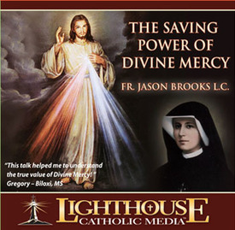](http://www.lighthousecatholicmedia.org/store/title/the-saving-power-of-divine-mercy?promoCode=105156)