Narrating Islam as the Early Warrior Cult: the scholar's speak

by Brent Waterbury

copyright 2015

"Not every organization which calls itself 'religious' is religious."
Commission on Cults
("Cults & Consequences: a handbook", Andres/Lane, ed., 1986)

As one who's been around religion for decades and authored several other books on religion I feel qualified but from a new angle. Twenty years ago few would have bothered on this subject but look at what's transpired in Islam the past 20 years? The religion has garnered the press worldwide but the tone is usually negative:

“I came to the absolute conviction that it is impossible…impossible…for any human being to read the biography of Mohammed, believe in it, and then emerge a psychologically and mentally healthy person.” - Syrian Psychiatrist and author
Dr. Wafa Sultan

One might say, 'Alright we've heard enough about Islam on the news. Why go after the entire religion over a few bad people?' Well this is the point of this ebook-- over the centuries Islam didn't start as a religion but historical evidence does point to an early warrior cult. What's very perplexing is this view isn't really out there for others to discuss. But why try to hide a religions theology? As the narrator this is the view of 100's of historians and scholars regarding Islam's bleak early history:

"Radical Islam is on the march across the Middle East." Bobby Jindal
("President Obama Created Donald Trump", Wall St. Journal, March 4, '16)

Today many in the West seriously question this strange, off-beat religion and don't know its origins except for a "Mohammed" who brought us the Koran. Yet what if new research found that Mohammed himself was legend or worse never existed at all? What if the Koran was meant as clever propaganda for early medieval jihad? Why did Islam as an Arab religion try to supersede Judaism and Christianity and not coexist? How did an early cult evolve into an Arab creed and from there into an Arab religion? This ebook tries to answer these very important questions which I feel are paramount:

"The psychology of zealous groups has not been a popular area of research."
("Cults: faith, healing and coercion", Galanter, MD, 1989, pg. 9)

Since Islam's early inception in the 7th century the West has dismissed it as a culturally backward religion and to be honest I never thought much about it either until 9/11. About a month afterwards I traveled to Manhattan and ground-zero and looked at the site and it was shuttered up and nobody could see in. New Yorker's were carrying on but there was an eerily silence as the banter and horns I heard before halted (NYC without horns?). A few years earlier friends and I had drinks on the 100th floor of "Top of the World" and now that was just a stolen memory. The people in NYC may have been still in shock then and I certainly was too. Not just that two 100 story skyscrapers were rammed by jet planes but almost 3,000 people were dead in a matter of hours:

"I can't count the amount of hate mail and threats we have received." Ibrahim Hooper, spokesman for CAIR
("Attacks against Muslims multiplying across US", LA Times, Dec. 11, '15)

To my knowledge there hasn't been a religion in history told to "slay unbelievers", or in that case pagans, since the early Israelites in 300-500BC as mentioned in Joshua, Kings and Numbers. But today "minimalist" archeologists in Palestine/Israel believe that this early genocide was more a nationalist fable any way and not could have happened in real life. Their archeological records have also disproved a large Israelite population in 800-1000 BC anyway so the Joshua story was really fiction to begin with anyway:

see, "What did the Biblical Writers Know and When Did They Know It", Dever, '01

"Most Islamic countries are caught in a permanent crisis incapable of structural reforms."
("Islam: past, present", pg. 608)

'Radical Islam is fast becoming the world's #1 problem." Ali
("Heretic", Ali, liner)

But now among the intelligentsia the question of Islam as a "non-religion" really isn't out there as since Islam is considered a great religion (more probably from numbers though). In today's PC world people are afraid to even answer out of fear of being branded anti-religious bigots or an Islamophobe--as if that might be the worst label in the world. But today that notion has been stretched so far out of context that even criticism of other religions is considered hatemongering and off limits. For example, even former president Obama in a White House press conference said that the terror group ISIS is "not Islam." Not Islam?? What are they 'Prez, Mormon's?:

"ISIL is not 'Islamic.' No religion condones the killing of innocents." Obama
("Strong Reaction to Obama statement", CNN, Sept. 11, 2014)

Here, the former president was sincere but sincerely wrong out of fear touching the Muslim 3rd rail.This is puzzling since many academics are supposed to further research in order to get to the bottom of things:

"Revisionism, like all forms of established bigotry, rests on several assumptions. Assumption #1: Muslims invariably lie and can't distinguish fiction from fact."
Khaled El Fadl, professor of law UCLA

(from "On Revising Bigotry", Scholar of the House, Fadl)

"Jihad is primarily about self-improvement... Islam is primarily a religion of love and compassion."
("Islam in Retrospect", Mahmassani, pg. 342)

These statements are typical of defensive-minded Muslims where any outside criticism should be essentially dismissed:

see also, Council on American Islamic Relations (CAIR)

"While it's true that there have always been Islamic thinkers who have tried to reconcile Islam with reason the fundamental precepts of Islam make the task extremely difficult."
("The World Turned Upside Down: the global battle over God, Truth & Power",
Phillips, p. 147)

Political Side

"Muslims will always resist Western ideas such as secularism".
("Who Is Defining Islam?", p. 187)

As everyone knows Islam is heavily politically-motivated. It's that way because Mohammed in the Koran supposedly went through a 'political phase' so they just try to follow suit (taqlid). Yet how could or would believers "submit" to a political religion? This question is never asked! Today, the parallels would be like Americans "submitting" to the Republican Party or Democratic Party! Is Allah a Shi'a or a Sunni? A Wahhab or a Salafist? Amazingly, Muslims themselves still don't know the true answer yet fight on as if the answer will drop from the sky! Meanwhile the mass murder and utter contempt for human life and dignity continues worldwide:

"So far, the fanatics are interpreting Islam." Musharraf, President of Pakistan
(sourced from "Who is Defining Islam?", p. 175)

But for the U.S., protecting our self from Muslims bent on their utopian society through revenge, terror and fear has come with a price bordering on mindless insanity. In 2011, just on our peripheral borders alone we spent about $66 billion on "Homeland Security" or about $500 billion since 9/11. This doesn't include our Defense Dept. military budget around $500 billion a year with its very pricey toys.

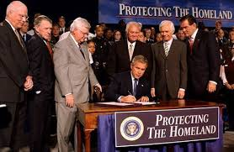

Bush signing Homeland Security Act, 2002

This means that since 9/11 our military has conservatively spent about $7,000,000,000,000 on wars overseas! These wars have all been with Muslims. The religion with 'Allah up there somewhere in the cosmos' has cost America with our Founding Father pluralist ideals a pretty penny:

"In the Muslim world extremism is mainstream. The sad reality is that most Westerner's haven't read the Koran and hadith and have no idea what is to be found in Islamic teachings... Islamo-fascism is an ideology coming from one source: the Koran."
("Because They Hate: a survivor of Islamic terror warns America", Gabriel, '06, intro, p. 105)

In 1998, Bin Laden laughed at America and called us basically a 'paper tiger... a dog with no bite'. To him his religion was a 7th c. literal war with "unbelievers" and he wasn't fooled by the Koran's double-meanings. While to us at the time Islam was the "religion of peace". Then '9/11'... Afterwards, one ex-Muslim doctor cryptically wrote in her book: "They are here." Meaning the monster is outside the door:
("A God Who Hates", Wafa Sultan, '11)

"Responses in the Arabic press to the 9/11 massacres in NY/Washington were an uneasy balance between denial and approval."
("Crisis of Islam", pg. 155)

All things considered, this means Muslims can be religious lunatics (like a bin Laden) yet within the umma still be considered devout without a fear of being criticized. This is another reason why clerics can't or won't condemn terrorists or "extremists" without condemning their own religion to our own dismay:

"Muslims think invertedly. Upside-down. Anyone who resists the Will of Allah [the West] is decried as an 'aggressor.'"
("Muslim Anti-Semitism in Christian Europe", Israeli, '09)

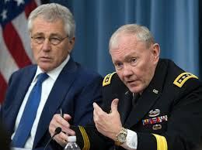
Defense Sec. Hagel

From the pic above we can see that the former Defense Dept. brass was stymied at fighting these asymmetrical wars overseas where America ends up with crap on its face. In theory we'd all like to help, for example, the Syrian people, its civilians, women and their children against a psycho like Assad. But if we go in to help extremists in the Muslim world decries us "Christian crusaders". Damned if we do, damned if we don't... So politically, we stand on the sidelines and wait:

"The pervasive and continuous conflict in the Middle East–between clans, tribes, sects, and religions–is a manifestation of this culture.”
(Middle East Forum, "Tribalism drives Middle East Violence", March 25, '16)

Twenty years ago the sectarian divide in the Middle East was just a little wood fence. Now thanks to their more literalist interpretation of the Koran the divide is a 20 foot high concrete wall encircling neighborhoods and entire countries: Syria, Algeria, Egypt, Yemen, Nigeria, Iraq, Afghanistan, Chechnya, Pakistan, Philippines, Indonesia and even parts of western China. Obviously that's their problem except the West gets sucked into their vacuum:

"In the Arab world the clock has stopped. The calendar is still set at the 7th century. They have lost everything, except for the Koran to which they cling to ever more strongly."
("The God Who Hates", p. 177)

To me, as a researcher of religions these scenarios make little sense unless of course that religion is not a real religion but a pseudo-religion or religious cult. Now these anti-social, psychotic attacks worldwide begin to make sense:

"For some, the Quran is regarded as the root of the problem."
("How to read the Quran", Mona Siddiqui, Phd, '07, pg. 7+)
_____________

Religion defined
1). the belief in a god or in a group of gods.
2). an organized system of beliefs, ceremonies and rules used to worship a god or a group of gods. (Webster's)

Myth

"All mortals create myth... On the side of human consciousness myth still lives and reigns. I call it the 'myth dimension.'"
("Global Myths", pg. 21)

Myths are usually about things that were once presumed to be true but over time are found out to be false and misleading. They are no longer valid. In ancient times there was very little “fact” so what we would consider myth was commonplace. Few could read or write (including Mohammed). Legitimate history or cross-referencing data would be a 1000 years off and basic education not even a dream...
The early Arabs were non-literate peoples all the way up to the early 20th c. and thus gullible to anything placed in front of them. Notwithstanding, there is also myth in both Judaism and Christianity but few believers note that.

(Max Roser (2015) - Literacy- OurWorldInData.org)

Pre-Islamic Arabia

"Allah is pre-Islamic."
("The Evolution of God", p. 339)

To speak of a self-proclaimed "prophet of God" one must be acquainted with the culture and background of Mohammed. This same idea would go for studying, say, Moses or Jesus. The more we know about their personal surroundings the more we understand the things they did and said or, more importantly, didn't or could not say:

"'Primitive religion' denotes the religion of non-literate people. Among those there is a deep reverence for raw superstition."
("Evolution of God", pg. 10)

As we know, most of Arabia is desert with very little rainfall. The bedouin tribes throughout Arabia were semi-wanderers and avoided the few cities. They were called "Saracens" by both Romans and Persians. These Arabs never acknowledged any authority other than their tribe and lived century after century without any government or laws:
("The Great Arab Conquests", pg. 1-15)

"Tribalism took precedence over ethics... Arabs were anarchists by instinct. War was a permanent institution of the Arabian society and eternal peace held no appeal to them."
("Arabia Before Islam", www.al-islam.org)

"Mecca was the stronghold of the old pagan cult [Ka'bah] which gives the city its importance... It possessed no codified laws." 2:144
("Outline of History", vol. 2: Roman Empire to the Great War", HG Wells, 1919, pg. 69-71), ("In Pursuit of Justice", pg. 3)

In the 3rd c. Iran (Persia) had colonies in eastern and southern Arabia while in the north Roman Byzantine armies ruled. At this time (and outside of the Holy land) all peoples in the world were pagan or believed in multiple gods. Mecca was land-locked and was more a stopping point for north/south caravans from Yemen to the south. I believe possibly just 500 people would flock to the Kabala, worship the gods and leave. There was little to do and no economy to speak of, while other cities were hundreds of miles away:

"Allah's most frequently used title, ar-Rahman (the Merciful) signified a pagan moon god."
("Islam, Mohammed and his religion", Jeffery, 1958, pg. 85)

("Story of Civilization", vol. 1, pg. 291), ("The Early Prophets: Joshua, Judges, Samuel and Kings", Fox, '14, pg. 7), (“Meccan Trade and the Rise of Islam”, Crone, 1987, pg. 246)

"The bedouin of central Arabia had been consigned to a state of arrested development... Arabs were warriors who acknowledged no master. In their disdain for the norms of civilization...they were despised but also feared."

(Cambridge History, pg. 22), ("In the Shadow of the Sword", pg. 54-6, 231+)

"...a race of men equally devoid of reason and religion."
Arab historian Abul al-fida, 1310 AD (sourced from "Decline/Fall", pg. 977)

Apparently different tribes had raided the area for centuries but not in a collective effort. But both the local Roman's and Persian's to the north hated them:

"Arabs constantly raided along the northern desert margin where Persian power was too weak to prevent them."
("Great Arab Conquests", pg. 107)

"They [Arabs] make off with whatever they can seize." Ammiamus, Roman historian
(14.4.1)

Coincidently, the later Koran wrote extensively about raids and fighting in a somewhat historical and not figurative sense. More importantly it writes about primitive Arab life which the reader sees behind the scenes as in a theatrical set. Today this is what 21st c. terrorists read into:

"The nomads lived in a state of raids but their hostilities still had a strict code of honor. But no tribe really aspired to exterminate or enslave another. In a sense, Arab tribal wars were scarcely a game. The object wasn't to win the war but rather to gain glory."
("A Short History of the Arab Peoples", Sir John Glubb, 1969, pg. 15, 24+), see also, "Arab of the Desert", Dickson, 1949, pg. 341

"In the Arabian desert people didn't feel secure. Raiding was the only way to stay alive and force was the law that governed. Tribes fought each other for food and water. Each tribe was afraid of being raided and felt secure when it got the opportunity to raid someone else. It was in this environment of fear that Islam was born."

("A God Who Hates: the courageous woman who inflamed the Muslim world speaks out against the evils of Islam", Dr. Wafa Sultan, '09, p. 51-62)

Ancient Arabia was a male-dominated society and still is. Women had no rights of any sort other than as sex objects, while hedonism and drunkenness were a common vice.

see also, "Jihad: origin of holy war in Islam", Firestone, '99, pg. 34, "The Great Arab Conquests: how the spread of Islam changed the world we live in", Kennedy, pg. 37, '07, "Muhammad: prophet for our time", Armstrong, '06, pg. 11+,
"Arabia Before Islam", www.al-islam.org

Mecca/Medina

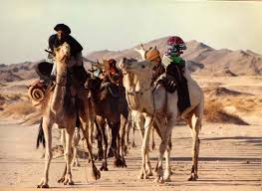
Saudi Arabia

"Propaganda is the use and manipulation of symbols. Whoever does it best is the best magician."
(Book of Lies, Levenda, "Magical Blitzkrieg: Hitler and the Occult", '14)

Mecca and Medina are about 300 miles apart but spiritually speaking in Mohammed's time they were galaxies away. In the region, early pagan religion had already made inroads while Arabian Jewish converts were perhaps in the region for a century before Mohammed, although very little is known about them:

"Medina lacked any sort of social structure or legal framework... Tribes often used brutality and oppression, and particularly at the expense of the underdog. 'Justice' was often retribution against a person and his family or clan, rather than attempts at fairness."
("In Pursuit of Justice", pg. 3)

Mecca (Mekkah) was a polytheist city (pop. 500?) 50 miles inland where pagans (Sabians) worshipped the stones and the sky. While Medina to the north, (pop. 1000-2000?) had a few small tribes of converted Arab Jews:

("Story of the Jews", Schama, pg. 235), ("Age of Faith", pg. 160), see also "Short History of the Arabs", pg. 26, "Mohammed: Islam's first great general", pg. 12

"In Medina, there were Jews [converts] who did the rites (midrashim) but had no Talmud."
("Islam: past, present", pg. 43)

No Jew could be a real Jew without a Talmud:

"Medina was different than Mecca....it was a little town... Mecca was probably never a great commercial center. Even in pre-Islamic times it was never easy to reach in any commodities we know of."

("Islam will Conquer", pg. 95), ("Short History...", pg. 26), (One Thousand Roads to Mecca: Ten Centuries of Travelers Writing About the Travelers Writing about the Muslim Pilgrimage, "Hajj Travel", Wolfe, Ed., 1997/2015)

Whenever someone today reads “according to Muslim tradition”, no matter who they are, note that these sources are roughly 150-200 years after Mohammed and anything could have been passed down. So unlike the later trumpeting from the 9th c. Koran, Mecca was a tiny town:

"No non-Muslim historian mentions Mecca in any accounts of trade in the 6-7th c. Nor for that matter do Muslim historians. There are no Islamic records of Mecca earlier that the 8th c."

("Did Mohammed Exist? Inquiry into Islam's Obscure Origins", Spencer, '12, pg. 104-6)

Spencer meant that the Koranic accounts of Mecca as a 7th c. trading center were possibly a century or more later than the Koranic version. So if one can imagine the remoteness, arid waste, heat and dust of Death Valley, California then one gets the idea geographically of Mecca. Thus a likely-hood of "God's only true Prophet" coming from a place like a Death Valley would be about as improbable as rain on the moon. This is an area that Muslims fear to tread:

(see map, "Arabia at the time of the Prophet" in "Islam: past, present and future", pg. 31), see also "Age of Faith", pg. 160

"There is no mention of Quraysh [Mohammed's tribe] and their trading center [Mecca] be it in Gr., Latin, Syriac, Aramaic or Coptic before the conquests [634+]. This silence is striking."
("Meccan Trade", Crone, pg. 134-7)

While in Medina just to the north was religiously mixed with Arab converts to Judaism. One modern Pakistani writer believes that Medina was 1/3 Jewish since they were booted out of the Roman Empire in the 2nd c.. But that itself is unlikely because Medina is roughly 800 miles of desert south of Jerusalem:

("Mecca: the sacred city", Sardar, '14, pg. 24)

"Islam was not an isolated, totally new monotheistic religion. Monotheism had been steady in both Semitic and Iranian [Zoroastrian] cultures for centuries."

("Islam: the straight path", Esposito, '88, pg. 6), see also Cambridge History of Islam, pg. 14, “Islam: past, present and future”, Hans Kung (Ger.), '04/07, intro

Again, the “Jews” were converts:

"Islam was born in a Jewish urban crucible."
("Story of the Jews", pg. 236)

Mohammed Ibn (son of) Abdullah--a short bio

"Anyone who obeys the Rasool [Mohammed] obeys Allah". 4:80

"Mohammed is accepted as the last prophet in the series...and its greatest member! His ascension to heaven is still celebrated. The Muslim community views Mohammed as the 'most perfect of human beings'. He is the last of the prophets including Adam, Noah and Jesus. Mohammed's message abrogates [supersedes] the revelations attributed to earlier prophets."
("Islam will Conquer", pg. 9, 81, 85, 102)

While the West has a somewhat different view:

"The West has a deep-seated prejudice against Mohammed."

("Mohammed in the eyes of the West", Montgomery, Boston Univ. Jnr. 22 #3, 1974, pg. 61+)

"Mohammed was a ruler and a soldier. Hence his 'struggle' [jihad] involved a new state and its armed forces--not a belief in God."
("The Crisis of Islam: holy war and unholy terror", Lewis, '03, p. 26)

"A cult leader is a claim that he is the sole agent of the divine on earth. God's agent. The leader is infallible--the possessor of absolute truth and total wisdom."
("Cults and Consequences", ch. 1)

"Mohammed was a military theorist, organizational reformer, strategic thinker, heroic soldier, revolutionary and inventor of insurgency. He proved to be a master of intelligence in war... Also his role as the Messenger of God."
("Mohammed", Gabriel, intro)

All Muslims know the past of Mohammed and most are quite happy with it. But in the Western view Mohammed is not a true figure of history, like say the Roman Caesar's (neither was Jesus but a composite-character written decades later). Even Muslims now admit that Mohammed has no cross-references to document for what he said or did except from “historians” 100 years later or more. Critics take note of this not only because of the 'merry-go-round' arguments in the Koran itself but the lack of what they consider a "3-D livable situation". The Jesus story would be called an identifiable livable situation for example. So historians take the view of Mohammed was a real bedouin warrior but who later turned into Arab legend and folk hero who wrote the Koran:

"Historically, Mohammed's true life is threadbare... That the Muslim tradition attributes the Koran and the Sunna to an illiterate man living in a pagan city in the middle of the desert is a problem--not a solution."

"In the Shadow of the Sword", pg. 54-6

"Little is known for certain of his life..."
("Heretic: why Islam needs a reformation now", Ayaan Ali, pg. 80, 2015)

"Mythology allows us to reconnect with a dimension beyond ordinary time. The ancient narratives provide a stage upon which cosmic forces can be seen in human form, acting out their dramas."
("Global Myths", Jon Young, PhD, curator, Joseph Campbell Archives)

Feasibly, Mohammed probably was a locally famous tribal warrior but was uplifted to "God Prophet" by later caliphs. This propaganda could have been used for the later generals as they scattered north for jihad. The logic then would be, 'why listen to a human general when there was a true legend?!? An Arab Prophet':

"It is a striking fact that such documented evidence from the Sufyanid period (661-684) makes no mention of the messenger of God at all. The papyri do not refer to him. The Arabic coins...only invoke Allah [God] not his rasul."

("God's Caliph", Patricia Crone, 1988, pg. 24), see also "The Quest for the Historical Mohammed", Warraq, 2000, "Hagarism: making of the Islamic World", Crone/Cook, 1977, pg. 18

Quite shockingly, so little is known about Mohammed that even Ivy League historians in medieval history need to use 2nd-hand Arab sources written a century afterward by known fabricators for their sources! (For a poor example of political correctness see, "History of the Medieval World", Bauer, "The Prophet"):

"To the Western reader there are grave difficulties in attaining a balanced understanding of the historical role of Mohammed."
(Cambridge History of Islam, pg. 30)

Only one Western Muslim scholar has gone on record claiming Mohammed to be
a figure of myth. But for our purposes here what we do know of him we have to deduce from the Quran. This is the 'token Mohammed' story that most historians in the West use.

( Muhammed Svev Kalisch, Univ. of Munster, "Professor Hired for Outreach to Muslims Delivers a Jolt", Wall St. Jnr., Higgins, Nov. 15, '08)

The basic story of Mohammed is that he was once a pagan who was influenced by local Jews in Medina. Apparently a spiritual man, he received revelations in Mecca from the angel "Gabriel" over a period of 20 years and wrote down what he thought he heard--even though legend has it that he was illiterate and an angel was writing for him:

("Jihad", pg. 202), ("Mohammed", Ibn Hisham, p. 65)

"[O Muhammad]: Whoever is the enemy of Gabriel [angel] should know that he revealed this to your heart by God's command." 2:97

"Mohammed saw himself as the Arab prophet who, like the OT/NT prophets, would lead the Arab's from a time of 'ignorance' [paganism] to the right path."
5:44-48
("Islam: past, present", pg. 108+)

"Mohammed didn't think he was creating a new religion. Rather he was bringing the old faith in the One God to the Arabs, who had never had a prophet."
("Islam: a short history", 'the prophet')

So the story goes, he preached his revelations to the polytheists in Mecca but in them were OT/NT visions of hell and monotheism which they didn't appreciate and they told him to buzz off:

"Bring us a Quran different than this or make some changes in it." they told Mohammed. 10:11

Upset, Mohammed flips them off and moves north to Medina with no more than 70 family members according to hadith tradition. There he told the local Jews of his prior revelations but they didn't believe them:

"Now someone has come to give you good news and warn you so listen to him!" 5:18

"Mohammed would be a leader of a new political order."
("In the Shadow of the Sword: birth of Islam & the rise of the global Arab Empire", Holland, '10, pg. 20)

One liberal Muslim doctor, now hiding over death threats, believes that Mohammed's Allah was a tyrant no different than the Jews cult of Yahweh, 500 BC, as recited in Joshua:

"Mohammed created an Ogre...to confront everything that frightened them."

("A God Who Hates: the courageous woman who inflamed the Muslim world speaks out against the evils of Islam", Wafa Sultan, '09, p. 51+)

"Mohammed extended the morality of the [tribal] blood feuds to religion... He redefined moral killing for political purposes."
("Mohammed", Gabriel, pg. 27+)

A political religion that endorses blood feuds and killing? Technically religion is supposed to be about Man's relationship to God like in the Old Testament; but I really don't notice that in the Koran:

"Mohammed believed he was doing God's work. Those who opposed him or his faith had to be eliminated."
("Mohammed: first general", pg. 104)

"Obey God and the obey the Apostle and those charged with authority among you!" 4: 59

In history there have been countless "enlightened ones" including Jesus, Buddha, Moses and Gandhi. But for his time Mohammed (or a peer) would be a genius as no one has come close to the catchiness of the writings for centuries. But there are detractors:

"Mohammed's claim of 'seal of the prophets' was not original. (33:40) It was preceded by Tertullian's Adversus Judaeos [Jewish Adversity] before 200 AD as a designation of Jesus Christ by the Latin Church Father's."

(Adversus Judaeos Vlll, pg. 12), (Das Siegal der Propheten, Colpe, pg. 28+, 169, 238)

It's doubtful that Mohammed read Latin so the "seal of the prophets" claim in the Koran was a later insertion:

"Mohammed shouldn't be called a 'prophet' because there is nowhere in the Koran or Hadith that he prophesied anything!"

("Islam is not merely a religion but a cult belief", interview with I.Q. al-Rassooli, Midnightwatchers blogspot, 3/22/13)

According to hadith tradition, Mohammed drove camel caravans across the desert. Later, he along with friends set out in normal Arab fashion on raids (razzias) in the hope of intercepting caravans on their way north. These raids continued for several years. According to tradition Mohammed himself led 27 of these raids while later biographers report over 100. He got 25% of the take:
("Islam Will Conquer", pg. 97)

"Mohammed was diplomatic, treacherous, vain, egotistical, tyrannous, ruthless and compromising as the occasion required. He was also a self-deceiver. There was singularly little spirituality in his kingship."
("Outline of History", pg. 72+)

That description could also read like decades later Malik or some other caliph which is one of my points:

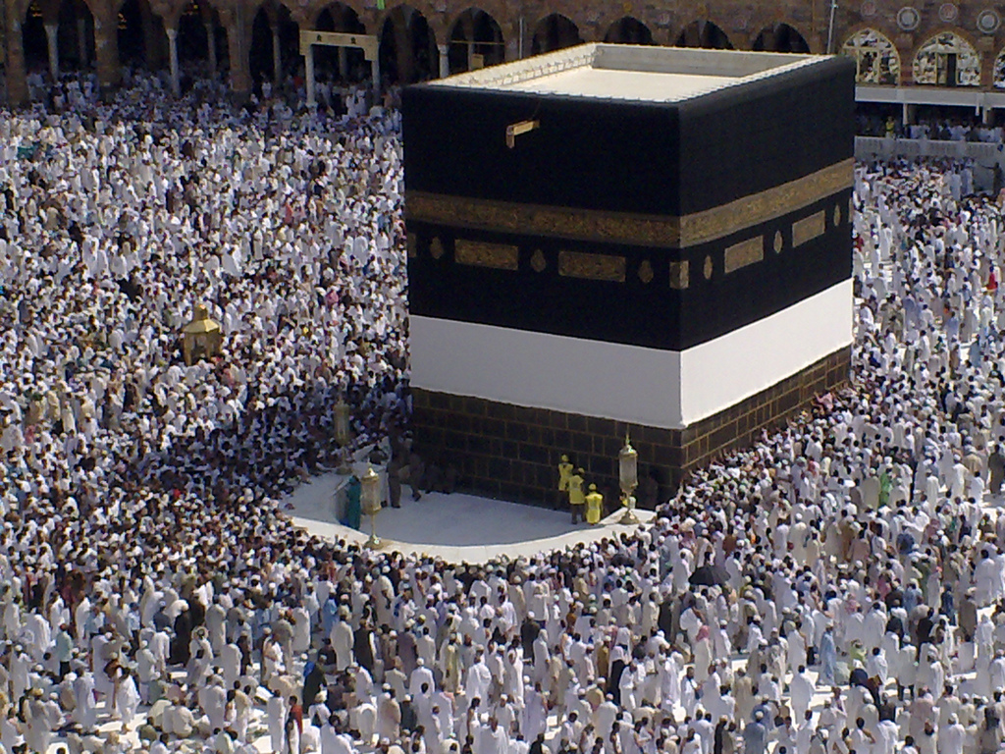

Millions pilgrim to Mecca paying homage to the Prophet. A lifetime goal.

"Men create gods after their own image." Aristotle 350 BC
(quoted in "Theories of Primitive Religion", Evans-Pritchard, 1965, p. 49)

What's odd about this treachery is Muslims worldwide are proud of these stories of 'stealing from the rich and giving to the poor.' Sort of like an Arab Robin Hood:

"The prestige of his military successes gave him almost autocratic control. He was given a piece of land, had a small house built with other apartments grouped around a central courtyard for each of his wives--a polytheist notion. He still continued to write verses and preach his monotheism. In later hadith accounts he was portrayed as often moody, wanting to be left alone."
("Islam Will Conquer", p. 96+)

Outside of the tribes the Koran doesn't claim exactly to who these "new believers" might be! It certainly wasn't directed to the Jews themselves. So according to the Koranic version he becomes a popular demi-god, cult-king with 11 wives. A man of true legend:
see "Short History of the Arab Peoples", p. 36

"The Arabs were in favor of the man but against the message."
("Mohammed: his life based on the earliest sources", Lings, '06, p. 59)

"There are verses that were revealed with the successive wars that the Prophet had to fight, in order to safeguard his mission."
("Islam in Retrospect: recovering the message", pg. 353)

As commonly assumed by radicals today, Mohammed did not set up an "Islamic state" in Medina as there were supposedly new tribal (or ridda) wars to come even after he died. While as a new regional religion, Islam wouldn't be in the cards until the later caliphs. Incredibly, this is a clue that Islam rather began as a small tribal warrior-cult that basically outgrew itself into what we see today:
see, "Evolution of God", p. 353

"In the [later] Medina phase, God's claim to 'authority' seems to have rested largely on battlefield success..."
("Evolution of God", p. 359)

"Mohammed was the driving force behind the Arab conquests."
("The 100: ranking top influential persons in history", Hart, '89)

"So when the sacred months expire [Ramadan] kill the Mushriks [polytheists] wherever you find them. If they repent and establish salah [prayer] and pay zakah [tax] leave their way. Surely Allah is most Forgiving. 9:5

"Allah was becoming more and more his own special God."
("Outline of History", pg. 77)

"Mohammed did countenance a lot of killings..."

("Evolution of God", p. 377, 392)

Prophets

"It is not Our way [God/angels] to punish anyone unless We send a Messenger.
17:15

For Mohammed to constantly call himself a "Prophet of God" in the Koran takes a lot of gall; but is still a point Muslims must be proud of because they wouldn't have a religion otherwise.
More importantly, I mentioned in another ebook that the history of prophecy goes back to about 600-800 BC with Balaam in the Old Testament book of Numbers. These "prophets" were not true seers but rather social prophets. They lived through a historical situation then afterwards wrote about it despite the prophets claiming 'Yahweh declares', 'Word of Yahweh came to me...' or 'Prophecy of Yahweh', etc. As of yet no man can ascertain the future--not even in the Bible:

"The genuine [OT] prophet is fully aware that he is a mouthpiece, no more; his words, though his own, are not his own... The true prophet is haunted by the idea of sin... the prospects of salvation however, are never forgotten.
(New Jerusalem Bible, "intro to the prophets", pg. 1159)

Of course I have no trouble believing that certain people are influenced by God to write out scripture (if it can be called that today). The Jews had their Major Prophets (Isaiah, Jeremiah, Ezekiel) with their Minor Prophets (Micah, Hosea, Daniel, Zechariah and others) which they used to help guide them with their new monotheistic belief. But they were skeptical as well. Something had to be proved first:

"Spurious prophets appear more than once in the Bible. Such prophets may be sincere but deluded, or they may be deliberate frauds; they aren't noticed by their behavior. They succeed in duping the people and the genuine prophets are forced to denounce them. Ezekiel condemns prophets and prophetesses in Israel. (ch. 13) Elijah appears as the champion of the true God when imported pagan cults are threatening the religion of Yahweh."
(New Jerusalem Bible, commentary pg. 1161)

Mohammed didn't claim to know the future but he did claim that his "revelations" superseded both the NT and OT! That would take gall! But if Mohammed was smart he should have added to the OT or Gospel accounts. Instead he (or a caliph) tried to negate both Judaism and Christianity as somehow old and irrelevant. Try telling that to a Catholic or a devout Jew:

"Oh believers do not make friendships with any but your own people. The unbelievers will corrupt you!" 3:116-20

Unfortunately this medieval concept still rings true in most of the Muslim world today.

Quran-- "recitation"

"We [Muslims] believe that the Quran is the exact unchanged words of God. The Quran cannot be corrupted by any changes. It is being protected and guarded by Allah himself!... The scripture demands absolute submission (islam) to God and his word... The correct interpretation has been a central concern of all schools of Islamic thought."
("Islam will Conquer", intro)

"The Koran has transcended all considerations of time and space."
(Encyclopedia of Medieval Islam, "Quran", Ayoub)

To Muslims worldwide the Koran is the "religion of God." In other words, if God came back to earth He (?) would each give us each a copy of the Koran to read, study and mull over as "eternal truth." But to the West however, that theme would be ridiculous and naive: God creates and doesn't need to write books to mankind from the Near East for others to mull over and argue about for a millennia. A Muslim apologist:

"The Quran is the primary source of guidance for Muslims. It is the only religious source of divine origin, as the literal word of God. However there is no Pope in Islam to control interpretation(s)."
("In Pursuit of Justice", intro, pg. 24)

Most Westerner's have not read the Koran and don't care to (paradoxically most Christians don't read their Bible either). Maybe it's the Arab lingo, the culture divide or the religion itself. My own stance is the Koran is not just a spiritual religion but also a creed of how and what to believe. And by all means it's not an easy book to read either as it was compiled in reverse with its time sequences convoluted.

While a novel approach in Arabia the Koran was instead written in the 3rd person with that person being the angel "Gabriel" (of the OT) telling Mohammed what to write down. But this 3rd person style of writing would already have been about 1000 years old already beginning with the OT Book of Jeremiah. For instance the OT runs very close to the Koran:

"The prophet dictated to Baruch all the words that he uttered in God's name over a period of 23 years." Jer. 25-45 (New Jerusalem Bible, pg. 1166-79)

"Those who are being scorned and refuted by the Prophet lurk off-stage. Their voices unheard, their beliefs unaired."
("Shadow of the Sword", pg. 308)

Later, Caliph Abu Bakr, the first leader of the Muslim community after Muhammad, that ordered the collection of all Koranic material in the form of a book. The final written form was completed under the direction of the third leader, Caliph Uthman, around 650 A.D.. Archeologically, and as recent Muslim luck would have it, some very early dating of Koranic fragments has been found of all places in an English library! These have been dated around the mid-7th century or just 20 years post Mohammed:

“At this time, the divine message was not compiled into the book form in which it appears today. Instead the revelations were preserved in ‘the memories of men.’ Parts of it had also been written down on parchment, stone, palm leaves...This means that the parts of the Koran...can be dated to less than two decades after Muhammad’s death,” David Thomas, professor of Christianity and Islam at the University of Birmingham

("World's Oldest Koran Fragments Found in U.K.", Discovery.com, July 22, '15)

While some other Western historians say 'big deal' anyway:

"Islam's early true history is an almost impenetrable darkness."
("In the Shadow of the Sword", p. 41)

"...[the Koran] is an endless, incoherent rhapsody of fable."
("Decline/Fall", Gibbon, ch. 1)

"The Koran was written in the poetic style of the desert... It is full of stories from the Bible and allusions to the Bible."

("Why Islam is a Cult", New English Review, Langone, PhD), ("Evolution of God", p. 335)

"Very little is known about the Quran's early composition."
("Heretic", pg. 95)

A great contemporary historian of religion:

"Contradictory instruction occurs throughout the Koran."
("Fields of Blood", Karen Armstrong, pg. 184)

"The Koran presents a strange face to foreigners."
("The World's Religions", Huston Smith, 1958/1991, pg. 234)

Admittedly, there are some ideas about fairness and how to live in the Koran. But there are also other ideas about fighting, slaying, slaves and injustice. How might one decide which to follow? This is also the Bible's problem...

Koran as a creed

"'Universal' shouldn't be construed to mean that an interpretation made 15 centuries ago should continue in effect universally forever. Universal means that it should constantly adapt and evolve over time.”
("Islam in Retrospect", pg. 355)

"The Koran was revealed to a people and culture very different from today. Their practices shouldn't reflect on the Koran.
("In Pursuit of Justice", pg. 398)

Today there's no disagreement that the Koran was compiled in reverse with the early war-like verses coming from the later "Medina period". Supposedly the earlier verses were from Mecca where Mohammed left with his small group. Still bear in mind that these still are accounts of tradition pieced together centuries later since the Koran doesn't speak this of itself. It has more important things on its mind:

"The Koran gives rise to different interpretations, with no monopoly on correctness in human hands or any school of thought.”
("In Pursuit of Justice", pg. 383)

While Malik is very level-headed and doesn't put a stratospheric label on it:

"Whether one believes the Koran to be a revealed book or not is up to the individual."
(Al-Quaran, Malik, pg. 104+)

The Koran has three main topics:

1. There is only one God (Allah).

2. Allah has assigned Rasools (Prophets) to deliver His message. The aim of the revelations is to invite mankind to the Right Way and present Guidance which he has lost. Mohammed is the most important Rasool.

3. Day of Judgment

One of my claims is that the Koran was set up to make enemies with other religions. This was its early propaganda with the warlike bedouin tribes who the caliphs or possibly Mohammed needed as warriors for their jihad north. The Koran highlights this idea but almost always in the negative towards the new believer. Apparently the guilt-trip paid off:

"Allah is not going to forgive them: because they have not believed Allah and His Rasool [Mohammed]. Allah does not guide transgressors!" 9:80

And nowhere in the Bible is a "prophet" exalted so high as the one in the Koran! Even Jesus had some humility:

"We sent forth Our Prophets one after another: every time a Rasool [prophet] came to his people they disbelieved him, so We punished them one after another; so gone is the nation of disbelievers." 23:44

Another giant of history, with books spanning 11 volumes, feels that the Koran was "half poetry-half prose" and not a religion at all. And due to the popularity of early Arab poetry I would agree:

"The poet to the Arabs was their historian, satirist, newspaper, oracle and call to battle. The poetry was usually about love or war. There was even poetry contests every year at Ukaz fair. Whoever won a prize his whole tribe felt honored and rejoiced."
("Age of Faith", pg. 159)

Can one imagine starting a religion built on Arab poetry? But trying to be fair here, the Koran can be great literature (in parts); while elsewhere it can read like a horror story from Frankenstein. While imaginative, critics say its theories are outlandish and absurd and it seems more of a law book for its tribal culture than an actual religion--the biggest reason why Islam has remained in the Middle East. And for a book that Muslims claim comes from God himself, the "Prophet" would often be on the defensive:

84:20, ch. 88, (Al-Quran, forward), see also "Evolution of God", p. 433

"This is scripture wherein there is no doubt! Ch. 2

"...their companion [Mohammed] is not a madmen; he is a Warner!" 7:184

"Those who offend the Prophet are cursed by God!" 33:57

Having written a book about both the Old/New Testaments the Koran can feel plagiarized:

"He was accused of having written the Quran himself or borrowed from Jewish and Christian sources."

("How to read the Koran", p. 38), see also, "The Lives of Mohammed", Ali, Phd, '14, p. 58, "Mohammed", Andrae, p. 11

Today people in our modern age don't realize that all ancient religions have myth or mythical elements in them. The reason being there must be a hero in there somewhere. For example, in the OT the hero's were Abraham, Jacob, Moses, David and the Prophets. In the NT, it was Jesus, Peter and Paul. Myths also have enemies too. In the OT the enemies of good were Eve, the Pharaoh and King Saul among others:

"What is the character of myth? A myth is always language robbery. No primary languages are safe from myth and articulated languages offer little resistance."
("Mythologies", Barthes, (Fr.), 1957, pg. 242)

As noted, Muslims believe the Koran has "transcended time/space" but the original 'Uthman' edition (644-56) did not have vowels or capital letters in it until 1923. Its words and sentences were run together like the ancient Hebrew scrolls for 1200 years:
see, "Age of Faith", pg. 158

"The original Uthman copy did not survive; even according to Islamic tradition."
("Did Mohammed Exist", pg. 198)

The "original" Bible has not survived over time either:

"...the text was in consonantal script so that numerous words and verses were ambiguous and open to misinterpretation."
("Islam: past, present and future", Kung, (Ger.), '07, pg. 69, 78)

One scholar who studied ancient manuscripts from Yemen led him to conclude that Koranic texts predated Mohammed by a century! He feels that the Koran eventually evolved under the later caliphs:

"About 20% of the Quranic text is just incomprehensible. The Quran claims repeatedly to be clear but obviously is not." Linguist Gerd Puin

("What is the Koran?", Lester, Atlantic Monthly, Jan. 1999, p. 283), see, "Quest for the Historical Muhammed", Warraq, ed., 2000, pg. 35, "Heretic", pg. 96

"The classical Arabic of Mohammed was to cause great difficulties for Islam (and still does). Because of its antique language it was understood only vaguely by the people."
("Islam: past, present and future", pg. 205)

As mentioned, the Koran repeats itself over like a bad salesman trying to hit its readers over the head:

"Time-wise, the setting of the Koran is problematic. For the great amount of repetition, interpolation, contradiction and dislocation within create significant [historical] challenges."
("Jihad: origin of holy war in Islam", Firestone, '99, pg. 44)

"Its definitive text wasn't achieved as late as the 9th c."

("Jesus in History and Myth", Hoffmann/Larre, '86, pg. 48), see also, Jam 'Al-Quran, , "Codification of the Quran Text: a comprehensive study", Gilcrest, MERC, South Africa, 1989)

Even though both are considered conflicting major religions, Christianity and Islam still have something in common:

"Sacred books make poor candidates as places for hearing God's voice. First, God's voice has to pass through human filters, memory, language [and culture]. How can we trust that someone's claim to be God's spokesperson is not just a skilled manipulator? How can we know they weren't lunatics?...Why rely on ancient revelations made under highly suspicious circumstances?"

("How to Create Your Own Religion", pg. 39, 41)

Like the early Bible, I truly believe the Koran was clearly meant only for a small, tribal audience:

"In the Quran, matters that typically require faith are limited."
("Islam in Retrospect", pg. 392)

In the Koran, jinns are used dozens of times. In Arabian mythology they were genies but could be either good or bad:
(6:100, 112, 128, 18:50 + 35 more)

"Mohammed used Arab superstition [jinns] as a source."

("The False Prophet", Newcomb, 1844), see also "Hero with a 1000 Faces", Campbell, 1949

Surprisingly, jinns were also used also in Indian Buddhist mythology in the 8th century. This means that the Koran was either still being written around Sind at the time the Muslims conquests or else the writers had come across the term from the outside. But how would a pagan Indian language invade new monotheist Arabia? It could not. So the parallel here to Mohammed's legend from this pagan Indian text are simply amazing:
("Encyclopedia of Angels", Guiley, "jinn", 1996, pg. 101), see also "Age of Faith", pg. 160

"...a supernatural voice urged him [Padmasambhava] to abandon worldly things. So by killing some of his father's retainers he succeeded in obtaining banishment from the kingdom. Dakinis [female gods] and Jinns [invisible devils] brought him the magic horse. After resorting to meditation in cemeteries, and there winning supernatural powers through the favor of the gods, he traveled through all lands... He set himself to the conversion of India corresponding to the local faith... On the completion of his mission he departed on the steed in order to carry the doctrine to the land of the western demons, among who he still dwells and preaches his faith."
("Mythology of All Races", vol. 6, p. 208+)

The Koran can also be very ambiguous at which point Muslims hem-and-haw and get evasive. Yet if it was "God's word" then it should be able to communicate clearly to its readers:

"Some verses are clear revelations and others are allegorical. Trying to explain allegory's will cause dissention!"
("Islam will Conquer", p. 123)

During the Middle Ages, Europe felt the Koran itself was beneath even paganism which it supposedly superseded! This is the opposite of what Muslims believe today:

"I regard it as a form of decadence rather than a form of progress in relation to paganism itself." de Tocqueville, 1780's
(sourced from, "Sword", pg. 208)

"Human beings naturally seize on strange, surprising things. But strange, surprising claims are often untrue. My assumption of the Koran is that Mohammed was doing the tailoring--even if convinced that God was doing it."
("Evolution of God", p. 466, 343)

"In the Quran, the relationship between correct rule and divine will remains elusive... The discussion of political order is absent... The Quran will remain at the heart of Muslim belief and will be used to engage in conflict as well as reconciliation."
("How to Read the Quran", Mona Siddiqui, '07, p. 94+)

Verses Mohammed Could Not Have Written...

The Koran appears to be written by several people instead of just Mohammed. The problem for Islam is Mohammed was supposed to be the only one doing the writing:

"...Neither the style, structure or content of the Koran suggests one source."
(Quranic Studies: sources & methods of scripture interpretation, #31, Wansbrough, pg. 134, 1977)

There was no complete Koran in Mohammed's lifetime. One of the greatest minds of the 20th century:

"In Mohammed's lifetime there was no collection of fragments from the Koran. So the nature of the nature of the book doomed it to repetition and disorder. But we are not sure he wanted all these fragments gathered into one book. Many of them were to the moment; they can hardly be understood without the commentary of history."
("Age of Faith", pg. 175)

According to tradition the angel Gabriel was supposedly dictating to Mohammed. Not unusual if one considers that in the OT of Zechariah 1 an “angel of the Lord” did the same thing. But here the Koran wasn't even written out yet:

"When the Quran is recited listen to it with full attention..." 7:204

This verse reads more a later Caliph who might be crucifying rebellious Christians, Persians or pagan Berber's in North Africa or northern India:

"The punishment for those who wage war against Allah and His Rassol [prophet] and strive to create mischief in the land is death or crucifixion or the cutting off of their hands and feet or exile from the land. 5:33

Unknown to Westerners there are words in the Koran that are not Arabic and have no equivalent in that language, meaning some of it was written outside of Arabia:

"The Koran wasn't written in Arabic [perhaps Syrian or Aramaic] but was rendered as the new religion was being developed for the unity of newly conquered domains."

("Did Mohammed Exist?", pg. 166), see also, "Syriac Influence on the Style of the Koran", Warraq, "What the Koran Really Says", pg. 175-87, "Christianity and the Arab World", bin Talal, 1998, pg. 10

"People of the Book"--Jews and Christians

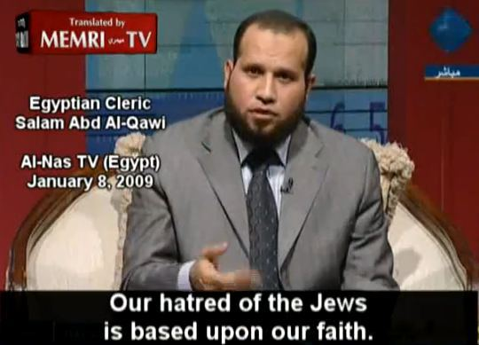
video still from Memri.org

"It is like sport to a fool to do wrong." Proverbs 10 (200-400 BC)

The big reason why I push that the Koran was written for later jihad is the caustic way it treats other existing religions. In the Koran, the term "People of the Book" are used dozens of times and refer to Jews and Christians. Apparently to whoever wrote the Koran they were jealous of the "People of the Book" and were trying to keep these other tribes away. A Muslim view:

"The God who revealed his Word to Mohammed is identified with the God worshipped by both Jews and Christian's. Although these communities failed to hear God's revelations to their prophets."
("Islam will Conquer", pg.)

While the non-apologetic West has a different view:

"The Koran doesn't show the slightest comprehension of Christian dogma and theology."
("Islam: past, present", pg. 115), see also "Age of Faith", pg. 185

Continuing:

'Islam is enemies with other religions.'
("The Great Theft: wrestling Islam from the extremists", el Fadl, PhD, '05, pg. 12)

"The obvious source for most, if not all of this material [Koran] was rabbinical literature. Stories were gathered from folklore, including biblical folklore to flesh out a salvation history."
(Quranic Studies, pg. 127-135)

In the Koran, Christians are mentioned about 15 times but apparetnly the writer ran into Jews and not Christians in Medina. The Christian villages were about 800 miles north in Palestine or 500 miles south in Yemen. This fact alone means that Mohammed could not have written the Koran by himself:

("Narrating Early Religion, Judaism & Christianity: the scholars speak", 2014, pg. 170+ ) see, "Islam in Retrospect", pg. 347

"Mohammed claimed that he had been sent to restore the 'religion of Abraham.'"
("Short History", pg. 32)

"The religion Mohammed wanted the Jews and Christians to accept was himself...as political leader."
("Evolution of God", p. 364-8)

The Koran claims to supersede both Jewish and Christian scriptures under the label of "falsifications" yet gives no real legit examples except that they "do evil." (5:57-82) To devout Muslims, both Jews and Christians are spiritually deaf and hopelessly lost. For example:
see, "Knowing the Enemy", pg. 48

"O people of the Book (Jews/Christians)! Now Our Rasool [Mohammed] has come to reveal much of what you concealed in the Holy Book. There has come to you from Allah a new Light and clear Book! 5:14-16

"Stories about Noah, Abraham, Jesus and Moses appear throughout the Koran. But if the reader expects a coherent narrative...he may end up feeling a little frustrated."
("How to read the Koran", pg. 23)

The Koran states that Islam is a "religion from Abraham" (Ibraheem) and that Abraham was first a Muslim--meaning a monotheist and a person of good judgment:

"We follow the faith of Ibraheem [Abraham] the upright one." 2:134-37, 2:124-130, 2:139
(Abrahamic verses: 2:133,136, 140, 2:260, 3:33, 3:67, 3:84, 4:54, 6:74-84, 12:6, 12:38, 19:41, 21:51, 29:27, 37:83, + 20 more)

"Adam and Eve invited their child to follow the Islamic way of life." Pakistani theorist Maududi
("Islam: an historical perspective", 1980)

But the West thinks differently:

"Moslems are allowed to lie and deceive the enemies of faith."
("Origin and Development of Moral Ideas", Westermarck, pg. 94, 1917)

While the Koran apparently hates both their faiths and why they are enemies with the Jews to this very day:

"They (People of the Book) are those whom Allah has cursed; who have incurred His wrath; some of whom were turned into apes and pigs!" 5:60

"Surely those who disbelieve from among the People of the Book [Jews/Christians] shall be in the fire of hell. They are the worst of creatures."
98:6

'The Jews have perverted their scriptures.' 2:75-141

'The Koran has superseded both religions'. 3:48

Today this has made the Jewish Nation mad as a hornets nest where for political and religious reasons Israel refuses to acknowledge their neighbors--and of course visa-versa--all because of these inaccurate verses of ancient propaganda:

"[To the Jews] Mohammed's message was not new. His deep affection turned to violent fury when the Jews refused to acknowledge him as a spokesman for God."

("Jewish Literature", Teluskin, pg. 161) see also, "Islam: past, present", pg. 108) , "Evolution of God", pg. 364, "Age of Faith", pg. 169

"To the local Jews, Mohammed was a presumptuous, if not dangerous, pretender."
("Story of the Jews", pg. 237)

Regardless, Koranic verses can read very close to many Hebrew scripture anyway. Some historians assume many verses were just copied from either the Mishna or Gemara's which were early rabbinic commentaries. For example:
("Age of Faith", pg. 184)

"For the Lord loves judgment and will not forget his saints." Ps. 36:28,
400-500BC

Or the Koran version roughly 1000 years later:

"Allah commands justice, good conduct. He forbids injustice and rebellion."
(16:90)

I'm sure most readers have heard of Wahhabi Islam. They are literalists of the Koran in Saudi Arabia:

"The Koran rejected outright any relationship with Jews and Christians other than jihad."
("Wahhabi Islam: from revival and reform to global jihad", Delong-Bas, '04, p. 262)

The historian Durant feels that Islam was invented and not inspired by God at all:

"To Jewish theology, ethics, ritual and Persian eschatology [prophecy], Mohammed added Arab demonology, pilgrimage, the Kaaba ceremony and made Islam." Will Durant
("Age of Faith", pg. 185)

In the Koran, those who believe are "rightly guided" while those don't believe who are thrust into hell. Again Christianity at that time was also notorious for pitting "believer against unbeliever" so that may have been Mohammed's or some later caliph's thought process as well:

"...that Allah may purge the believers and destroy the unbelievers [mushrikin]!" 3:140

"It is He Who has sent His Rasool [Mohammed] with the guidance and the religion of truth to make it prevail over all religions!" 61:9

"Believe in the Book of Allah and Mohammed or fear the Hell fire!" 2:23

The Koran also has no concept of "salvation" like in Christianity. Salvation means that people are separated from God by sin and that God closes that gap through belief and right living. But Muslims don't consider themselves "sinners" even though they pretend to follow the faith of Abraham! This is why in their eyes they are perfect before God as is! No need to change or be better:

"In the Koran, 'salvation' is a polite term for what they have in mind."
("Evolution of God", p. 392)

"Most people end up espousing some simplistic fairy-tale version of what they believe their religion is about."
("Create Your Own Religion: how to book without instructions", Bolelli, '13, pg. 10)

The early Arabs weren't aware of their Bible history anyway since rabbis in Jerusalem put an end to prophecy after the 2nd Temple's destruction around 70AD. While other rabbi's say a 100 years before that! So to the Jews of the time anything past that point would be redundant as their Chosen Nation was over with. That alone should have ended Mohammed's "prophet" label. So over 1400 years later why haven't Jews ever brought this legitimate angle up? Why argue with guns and bombs when arguing and undermining scripture is easier? A Jewish view of the Koran:

"Unbelievers and Jews in particular were to be reminded of their humility and degradation in the sight of Muslims... Even worse than his [Mohammed's] blasphemously cavalier rewriting was the insistence that those who wrote the Torah [Jewish way of living] were frauds and forgers--requiring a correction from the Koran."
("Story of the Jews", pg. 237, 242)

"Tolerance was given to both Jews and Christians only on the condition they would submit to a system of persecution and total inferiority."
Historian Bat Ye'or
(interview, Books and Culture, Oct. 1998)

This is why devout Jews, especially in Israel, will not bargain with Muslims under any circumstances.

("Essential Judaism", Robinson, pg. 131), see also, "The Invention of the Land of Israel", Sand, '12, "The Mythic Past: biblical archeology & the myth of Israel", Thompson, '99, "The Israelites in History & Tradition", Lemche, '99, "The Bible without Theology", Davies, '87, "What did the Biblical Writers Know", Dever, '01

Muslim ("adherent of Islam")

"We are thinking beings and we can't exclude the intellect from participating in any of our functions." Philosopher William James, 1900
("The Varieties of Religious Experience", James, 1901)

As stated in the Koran, Muslims are the original "community" (umma) of the Prophet. (2:128, also ch. 3) But they wouldn't be called Muslim's, or noted as Islam, for another 300 years till around the 10th/11th century.

("Outline of History", vol. 2: Roman Empire to the Great War, HG Wells, 1919, pg. 69), ("In the Shadow of the Sword", pg. 384, 413) , ("History of the Medieval World", Bauer, '10, pg. 292), ("The Great Arab Conquests: how the spread of Islam changed the world we live in", Kennedy, '07) see also Cyril of Scythopolis, 24

As mentioned, all Muslims believe their religion superseded both Judaism and Christianity beginning with the Dome of the Rock shrine to Arabs (not Mohammed) which was built in Jerusalem 691AD. They believe it because it's written in the Koran in dozens of places. They believe in "sin" but not from the biblical concept view but from their own view:

"In general, Muslim's don't believe that men can be made righteous by moral example or persuasion."
("Short History of the Arab People", pg. 36)

"The virile Moslems would hardly claim to have fulfilled the ethics of Christ."
Will Durant
("Age of Faith", pg. 161)

Adherents of Islam today have an "us vs. them" mentality. To deny that is to take away their religion or make it 2nd or 3rd tier. They are not pluralists and never have been. Extremely rare is the Muslim who openly criticizes their faith. One Persian Muslim professor in England says that view is too constricted:
see, "Crisis of Islam", p. 43

"Muslims are convinced they possess the only truth. The Koran is a closed book which one can only read, write and obey is a problem fueled by many Muslims themselves." 18: 27
("How to read the Koran", embracing critical scholarship)

Most Muslims are obviously not friends with the West or America:

"Muslims are fearful of 'Americanzing the religion, the Koran and Mohammed's message.'" Sheikh Humud/ PLO
(MEMRI.org, "Friday sermon of Palestinian Authority TV", April 2, '03)

Cult followers are usually asked to do weird things to offset them from the rest of the normal world:

"Cult members are asked to turn their backs on the world outside."
("Straight talk about cults", pg. 82)

Outside of the Koran there would be no real reason for it. A hypothetical question:

"A significant number of Muslims are hostile and dangerous. Not because we need an enemy but because they do. They see the West as their ultimate enemy and the source of all evil."
("Crisis of Islam", pg. 28)

"If the West underwent a massive conversion to Islam the basis for Muslim 'hatred' would simply disappear." ("End of Faith", pg. 30)

Today there are many different facets of Islam as the Persian's or Shi'a would be considered the most liberally-minded of the bunch and basically want to be left alone. As we witnessed on TV the Sunni, or mainstream, won't let them:

"Most Muslims struggle to escape from the doctrine that Islam is perfect."

("The World Turned Upside Down: global battle over God, truth and power", Phillips, '10, pg. 149)

Most Muslims are fundamentalists where outside candor, criticism or truth is suppressed:

"Many Muslims are woefully ignorant about their own religion. They have suffered a crisis of authority that has deteriorated into full-fledge chaos... Westerner's often complain [to the author] whether or not Islam endorses or condemns hostage-taking or suicide bombers."
("Great Theft", pg. 11, 26+)

"Muslim's are 'insistently fixated on its heyday long past and suppress all tendencies towards reform and enlightenment.'
("Islam: past, present and future", Kung, (Ger.), '07, pg. 645)

"Where are the moderate Muslims?"

("Challenge of the Moderates", Hayden, college survey in Jakarta, Indonesia, April 24, '06, www.beliefnet.com), see also "Knowing the Enemy", p. 101+

Islam ("submit to God's law")

"All religions were born because someone departed from an existing religion [paganism] and created their own."
("Create Your Own Religion", pg. 20)

"Islam has been largely the creation of conquering armies."
(Cambridge History of Islam, Lambton/Lewis/Holt, ed., vol. 1, 1970, intro)

Islam claims to be the world's only religion that mixes politics with religion as one unified system. Like Judaism, its emphasis is more about a group mentality rather than the individual and has been that way since its inception:
see, "Jealous Gods, Chosen People", pg. 126, "Islam will Conquer"

"Islam is not a religion nor a cult but a complete system... It's understood primarily as an Arab religion."
("Islam: past, present", pg. 174), ("Slavery, Terrorism and Islam: historical roots and contemporary threat", Hammond, PhD, '08)

"Islam was not an isolated, totally new monotheistic religion. Monotheism had been steady in both Semitic and Iranian [Zoroastrian] cultures for centuries."

("Islam: the straight path", Esposito, '88, pg. 6), see also Cambridge History of Islam, pg. 14

History tells us over and over that mixing politics with religion hasn't worked out very well. For a quick example, the Catholics tried it up to the Middle Ages and only let go of their vise with the later Reformation in Germany. More recently, in the 1970's-2000 the Republican Party tried courting Right-wing Christians over abortion and even ended up on the covers of Time magazine. They later divorced:

"There is intense social pressure not to openly question the validity of Islam.... This rigidity and inflexibility is mistaken as a sign of piety."
("In Pursuit of Justice", pg. 379-82)

For example, during the 1980's the cleric Ayatollah Khomeini murdered between 20,000-50,000 Iranian people in prisons by trying to mix Islam and politics for its new Shi'a theocracy:
see, "Great War for Civilization", pg.

"Islam was a retrogression [slide downhill] from the traditional freedom and customary laws of the desert."
("Outline of History", pg. 91)

"Islam is discriminatory."
"Christians in the Land Called Holy", First Things mag, Malik, Jan. '99)

Worldwide, Islam is still blindly followed even with mass murder and genocide railed against them. For example, Europe is getting about 500,000 Muslim refugees a year yet its women cross the ocean still wearing their religious head scarfs! To not wear a head covering would be a "grave sin"! But anybody with horse sense should at least think twice about a religion where a dictator evicts its citizens from their own country as what's happening in Syria and Iraq. Where is their umma? What kind of religion is this? A valid religion would in the very least try to care for its own followers. Because Islam or apparently Allah doesn't care we must assume it is a cult:

"Islam is not a theology or theosophy [philosophical study of God]."
("Understanding Islam & Muslims", Sakr, PhD, '90, ch. 1)

"One might question the genuineness of a faith that is coupled with a resounding threat against those who fail to believe."
("Islam in Retrospect", pg. 325)

"Muslims are the first victims of Islam.” – Joseph Ernest Renan, French expert of Middle East ancient languages and civilizations.

"[Like Christianity] Islam advocates that faith and reason are incompatible...That the mind is useless with divine governance."
("Islam in Retrospect", pg. 390)

"When examined, Islam isn't much more than an obvious and ill-arranged set of plagiarisms, helping itself from earlier books."
("God is not Great", pg. 129)

American politicians believe Islam is a religion of some sort but don't know what type of religion. Yet even a former imam was honest enough not to defend Islam as a religion:

"Islam is politics or it is nothing." Khomeini
(quoted in "Knowing the Enemy")

In earlier medieval times this process was worked on for hundred's of years. Muslims know this but they look the other way because to them no other religions are valid:

"The imposition of Islam upon the entire world isn't their goal. It is their religious duty."
("Because they hate", p. 145)

A Muslim with a current best-seller:

"In the simplest terms: Islam is not a religion of peace... The long traditions in Judaism and Christianity of passionate debate and agonizing doubt are absent in Islam. Instead there is conformity."
("Heretic: why Islam needs a reformation now", Ayaan Ali, pg. 3, 66, '15)

In the U.S., Muslims are "peaceful" but only because they are less than 1% of the population. To no great surprise the greater the percentage of Muslims in a country the more they demand sharia. Another reason for our Islamaphobia:

see, "Challenge of the Moderates", Hayden, college survey in Jakarta, Indonesia, April 24, '06, www.beliefnet.com

"Islam seeks to alter the social order of the entire world. To destroy the old order so that utopia can rise from the ashes. As pretender's they are attracted to 'peace', 'justice' and 'equality' but actually stand for the opposite."
("World Turned Upside Down", pg. 270)

Except for the more metaphysical Shia's in Iran ijtihad is not encouraged:
see, "Journey Into Islam", pg. 35, 167

"Many Muslims still see the 'lunatic fringe' in Islam."
("Journey into Islam: crisis of globalization", Ahmed, '07, p. 191)

see Kitab al-Jihad, Wahhabi, p. 366, see also, "Jihad in Classical and Modern Islam", Peters, "Muslims: rewiring the house of Israel", pg. 218-285

Caliphs/ Post Mohammed

"The political community of Medina didn't have a far-reaching impact on Islamic political theory. The Caliphate play a more significant role... We can argue that these empires had no intrinsic "Islamic" quality to them.
("In Pursuit of Justice", pg. 29, 45)

"O you who believe, fear Allah and seek to be near Him and carry out Jihad in His way so that you may succeed.” 5:35

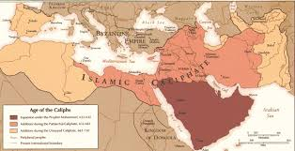

I've found the post-Mohammed period a very important time-line for deducing the later “cult of Mohammed”. Some verses in the Koran point to the idealist in Medina or Mecca while others point to jihad.
As well known, jihad has several meanings with the lesser one being peaceful or an "inner striving". The greater jihad is 'outer' meaning raids. There are over 150 verses in the Koran regarding jihad and to distinguish the two all one needs to do is read the Koran in context. In other words the Koran itself is its own worst enemy.

For example, in the verse above how might one "carry out jihad" internally? Clearly this is meant as an external jihad. Of course, the jihadists today aren't fooled by the academic apologists either. For example:

"I [God/angel] do not allow the labor of anyone to go to waste. Those who emigrated [north] and were expelled from their homes [tossed out] and were tortured in My way [raids] and fought and were killed, I shall admit them into gardens..." 3:195

Below is a 7th century Arab poem. Often these poems were about women or war and which historians have used to piece together the 'black holes' of Arabian history. This poem was a fight between two clans and is typical of the bedouin of the era:

"We came upon their host in the morning. We fell on them with white steel ground to keenness: we cut them to pieces until they were destroyed; And we carried off their women on the saddles behind us..." A 7th c. poem by Amir b. al-Tufuyl
("The Diwans of Abras, Tufuyl and Sasaah", Lyall, 1913)

Regarding Mohammed, no one knows when he lived or died. It's just presumed. Likewise Jesus who was also is not a person of contemporary accounts:

"His death at Medina (632) provoked a major crisis among his followers."
("Islam will Conquer", pg.

"Serious differences arose within the Muslim community immediately after the Prophet's death. According to the Sunnah [Sunni mainstream] the Prophet had designated no successor."
("Islam will Conquer", pg.) see "Great Arab Conquests", pg. 54

Later Arab conquering and raiding of the ME in the name of Islam are understood by Muslim sources today and knew religion wasn't involved for centuries. Most look back on the Tabari view of Islam written 300 years after Mohammed:

"The Arab chronicler's have been less than satisfactory, contradictory and the notes clearly written for a tribal audience".
("The Heirs of Mohammed: Islam first century and the Sunni-Shia Split", Rogerson, '06, pg. 62-4)

Some modern Islamic myths:

"When Mohammed died all of Arabia was under Islamic governance."
("Interpreting the Quran", pg. 121)

"Preachers and reciters of the Koran followed in the wake of the advancing armies!"
Cambridge History of Islam, pg. 89

The historicity of the Cambridge view would be like Constantine waving a Bible when he won the battle at Milvian Bridge! Another confusion overlooked is if the Prophet and his message were so important why no successor? According to hadith tradition Mohammed had 9 wives. So logically how would one have 9 wives but no sons? But since there was no one in charge of Islam what that might that say about this early religion? Was it that unimportant?

As historians know, early Islam did stumble badly and like early Christianity took centuries before it later became the religion for the masses:

"It is interesting how the early Muslims reconstructed their past and explained the coming of Islam. There are many foundation myths... The narratives are replete with confusion and improbability and are often impossible to accept at face value."
("Great Arab Conquests", pg. 2-5)

Another theme in this ebook is historical mavericks believe that the Koran was written backwards in time: they raided, conquered, then later wrote out the Koran as they now had a template. This trick really isn't new as Old Testament writer's ingeniously used these same tricks fooling both historians, religious Jews and Christians for 2500 years! Only recently have historians and archeologists uncovered a much different version of the Bible than the one that was written! In other words, virtually none of the Bible is documented history and neither is the Koran:

"The true believers are those who believe in Allah and His Rasool [caliph] then never doubt; and make jihad with their wealth [$$ for swords] and their persons in the cause of Allah [jihad]." 49:15

Of course the theory that the Koran would be written in hindsight would be sacrilegious to most Muslims when it was supposedly written forward:

"The leader of the new state were fully aware that it had to expand or collapse."
("Great Arab Conquests", pg. 65)

"The Islamic state could never survive as a stable Arab polity confined to Arabia."
("Jihad", Firestone, pg. 124+)

Kennedy believed there wasn't much religion at the time and certainly no god in Medina directing them for conquest. If you conquered and got booty then 'Allah blessed you'. While the figure Mohammed was up in the heaven next to Allah watching your every move:
see, "Islam will Conquer"

"Five sixths [80%] of the Arab population were nomad Bedouin's. They were useful for their military skills... but needed to be controlled and led."

("Early Islamic Conquests", Donner, p. 81), see also "Age of Faith", pg. 157, "History of the Arabs", Hitti, pg. 17, Cambridge History of Islam, pg. 58

Like an early proto-typical cult the Koran warned the Arab peasants to obey or else. For instance:

"The punishment for those who wage war against Allah and His Rasool [go against caliphs/generals] and strive to create mischief in the land is death or crucifixion!" 5:33

"The caliph has nothing to do with religion. It has more to do with a lust for power and the exercise of intimidation."
("Islam & the Foundations of Governance", Raziq, 1925)

"The decisive factor in this success was Islam which instilled into the hearts of the warriors that the belief against other faiths was a holy war and that booty was the recompense offered by God to His soldiers."
(Cambridge History of Islam, pg. 60)

Caliphs or generals were despots like a Saddam. They ordered and others obeyed under penalty. This centuries later hadith, which Muslims adhere to, bears this out:

"Die rather than yield... Compel the rest of mankind to become Moslems or pay us tribute [$$]. If they refuse these terms, slay them." Abu Bakr

(sourced from, "Greece under the Romans", Finley, pg. 369, 1877)

"Nominally, Allah is Islam's chief ruler. However, its true master has been whatever ruler was unscrupulous enough to hold the Caliph."
("Outline of History", pg. 91)

The Koran post Mohammed:

"O believers, shall I direct you to a commerce that will deliver you from a painful chastisement? You shall believe in God and His Messenger... He will admit you into gardens underneath which rivers flow and to dwelling places in the Gardens of Eden. 61:10+

As mentioned, conversions weren't exactly overnight:

"Conversion [mawali] of the majority took 300 years. Conversions of the subject people was a slow and long-drawn-out process."
("Great Arab Conquests", pg. 6)

After Mohammed croaked, Abu-Bakr and the early Muslim tribes battled Arabian pagan tribes for several years in what is famously called the "Ridda" or civil wars. This is significant because in the Koran account the Arab tribes were supposedly "brought together under one roof". But in reality apparently not:

see "Great Arab Conquests", pg. 105, "Heirs of Mohammed", pg. 125-158, "Islam will conquer", pg.

"After his death more than 70 memorizers (huffaz) of the Quran were martyred [killed] in the battle of Al-Yamamah [ridda wars]. The 'Oral Copies' were now lost but some manuscripts remained."
(Al-Quran, Malik, p. 783+)

"We [historians] cannot vouch for the truth of these tales."
("Age of Faith", p. 189)

Afterwards Bakr assembled very large armies of maybe 2,000-5000 (mujahidin)
and with "God's promise of booty" headed both north to Syria and east to Persia. The Koran itself spells this out:

see, "The Heirs of Mohammed: Islam's 1st c. and the origins of the Sunni/Shia Split", Rogerson, '06, pg. 125-158

"Know that whatever war booty you may gain, 1/5th is for Allah, His Rasool, [caliph?] close relatives of the Rasool, orphans, the needy... O believers! When you encounter an enemy in combat be firm so that you may be successful!" 8:41-45

"Surely those [polytheists] who reject Faith it doesn't matter, they will not believe. On their eyes there is a veil and there is a grievous punishment for them."
2:6, 7

"Half of Mohammed's rhetoric was for believers who after death 'lived in the shade by waters...couches...virgins'. The other half would be the place you would wind up if you weren't one of Mohammed's followers."
("Evolution of God", pg. 347)

Thus a cult of personality gradually emerged which is what Muslims read today 1400 years later:

"Cults are truly personality cults. They come to reflect the style and whims of the leader and become an extension of him."
("Cults in our Midst", Singer, PhD, '95, intro)

"The life of Mohammed becomes the model for the acquisition and use of power."

("Political Dimensions of the Sira", Siddiqui, Phd, Institute of Contemporary Islamic Thought", sourced from "Knowing the Enemy", pg. 132), see also "Outline of History", pg. 87, "History of the Medieval World", pg. 315

"Members of the cult find it necessary to identify with the leader-aggressor [caliph/ general] and sustain their dependency."
("Cults", pg. 106), ("Age of Faith", pg. 224), see also, "Mohammed: Islam's first great general", Gabriel, '07, intro

Quite amazingly, the Koran itself speaks of obtuse historical situations in these pagan lands. One can even visualize a caliph screaming this out to his followers:

"O you who have attained to faith! Fight against those deniers of truth [kuffars]... God forbids you to ally yourselves with those who fought against you over religion! Whoso allies himself with them--these are the unjust! 60: 7-9

As far as we know during the conquests there was no Islam, religion or a Koran in Medina or Mecca during Mohammed's reign so how could they have "fought over religion?":

"By 632, the Quran had neither been written down nor collected let alone canonized. The problem was how to build a cohesive religious system out of the Prophets word's and deeds--the majority of which solely existed in the memories of the Companions."
("No god but God", p. 110+)

"The conquests were masterminded by Umar...The Quran was compiled during the reign of the 3rd caliph Uthman (650). It is the primary source of Islamic law... 'Fight the oppressors' could have been said by Uthman in Syria."

("In the Shadow of the Sword", pg. 347-360), ("Wahhabi Islam, p. 12), ("Islam will Conquer" pg.), see also, "How to read the Quran", "Islamic Conquests", Donner, 1981

"Of the four rightly-guided caliphs, three were murdered at the hand of an assassin. ...The prestige of authority and the bond of religious loyalty was weakened to the breaking point by civil war."
("Middle East: brief history of the last 2000 years", Lewis, '93, pg. 62-65)

"In 694AD, Christians found not a single book but rather a jumble of fragments with such titles as 'The Cow' [2nd ch.] and 'God's She-Camel'...These were only the beginnings of a theology."

("Evolution of God", p. 390+), ("Islam: past, present", pg. 226)

While Crone and Cook think that Mohammed's salvation history was constructed closer to the later reign of caliph Malik: (690)

("Hagarism: the making of the Islamic world", Crone/Cook, 1977, pg. 18)

"Malik had troops to spare, troops who might appreciate booty and plunder to keep their loyalty."
("Great Arab Conquests", pg. 216)

If you didn't join their party then a devil was sent after you and you were sent to hell (58:10, 7:27, 2:23). If you tagged along you got stolen merchandise, slaves and women, later sold for money. You made like-minded friends along the way. If you died in war, then martyrdom, heaven and "chaste virgin spouses" (2:25). In some way the bedouin's came out ahead:
see "Decline/Fall", pg. 945

"There had been no detailed end-time scenario in the Koran. Paradise was described only in vague terms... All Muslims would have to abandon the ease of settled life and join the army, which would not only defeat Byzantium but complete the conquest of Central Asia, India and Ethiopia."
("Fields of Blood", pg. 190)

The conquest of Jerusalem in 637 is mentioned by Sophronius, the patriarch of Jerusalem, who turned the city over to Umar, the conquering leader. But nothing is said about a holy book or a Muhammad. Only that they were Saracens who were “godless”:

'Whence is Christ Himself blasphemed by barbarian mouths? The Saracen's have risen up against us because of our sins and ravaged everything with violence and beastly impulse and with impious and ungodly boldness.' Sophronius

(sourced from, "Seeing Islam as others saw it: a survey on Early Islam", Hoyland, '97), see the Sophronius account in Patro-logia Graeco-Latina, Paris, 1857

However, the Sophronius account was probably added centuries later as people of that time were known to do. First off, bedouin's didn't destroy the land nor kill people who didn't resist:
("Great Arab Conquests", pg. 111)

"The ideology of holy war and martyrdom for the faith was transmitted during the wars between Muslims and Christian's."
("Mohammed: Islam's 1st great general", Gabriel, '07, intro)

The cult of Mohammed preceded the roving armies--not the waving of the Koran which wasn't yet written out:

"The armies were bound by a shared ideology [conquest]. Nothing welds a people together like war."
("Prophet and the Age", Kennedy, p. 55), ("Islam: short history", the prophet)

On the other hand, these century-old conquests were no picnic. Only local bedouin's could have made the desert journey. The only way to cross the desert would be on camel or on foot since horses were too fragile and couldn't carry loads. So from the nightmare of Arabia itself maybe these armies left out of survival:
see "Mohammed: Islam's 1st Great General", intro

"There was a new elite religion but it seems to have made little impact on the environment."
("Early Great Arab Conquests", pg. 97)

"The conquests of the early caliphs were expansionary wars of the Arab tribes. Wages were low but plunder was vast."
("Islam: past, present", pg. 217)

The Koran speaks of the typical jihad of the time:

"Kill the idolaters [kitab al tawhid] wherever you find them, take them [as captives], besiege them and lie in wait for them. If they repent afterward, perform the prayer [Mohammed as prophet], pay the tax, then release them." 9:5, 29

Historically, Mohammed never could have said that since all of Arabia were idolaters! But a later general might have accosting Persians and Indians in later conquests would have.

see, "Greece under the Romans, Finlay, pg. 367, 1877

Dhimmi's

"The Koran has a pernicious, encouraging intolerance toward people not Muslim."
("Evolution of God", p. 329)

"Surely We [God/heavens] have prepared for the unjust [kafirs] a fire, whose tent will envelope them. 18:29

Under the 'Laws of Umar' the conquered peoples--Jews, Christians, Persians and Indians--were given 2 choices: pay the tax (jizya) or convert to Islam. Since people had no $$ at the time, and the Saracen's no complete Koran for possibly centuries, most simply "converted" by mouth declaring Mohammed God's Prophet. These people were called dhimmis, or 2nd class citizens. They were not much different than blacks in our 1960's:

“In Umar's empire the Arab's were themselves a small island surrounded by a non-Muslim and non-Arab ocean; something that condemned their apartheid policy to assured failure...As far as the Arabs were concerned the vanquished masses had only one role in life: to provide a lasting source of revenue for their imperial masters.”
(“Islamic Inperialism: a history”, Karsh, pg. 26+)

But in the later medieval period dhimmitude was easier for Jews than living under the militant Christians of the time. All over Europe Christians corralled Jews into slums calling them 'the devil incarnate' for killing Jesus. But Christians themselves weren't allowed to think outside of the Bible either so for a time they were rather envious of Moslems:

"Dhimmi's could be killed or enslaved."
("Moorish Spain", Fletcher, pg. 96+), see also, "Spread of Islam through North and West Africa", Kenny, 2000

Although no one talks about it (because few know anything about religion) dhimmitude currently exists in Western Europe where Muslim radicals run over their citizens with cars and trucks. Dhimmitude also creates fire-storms in the Middle East regarding other religions which are considered inferior and very long civil wars have been started because of it. For instance, Arabs in Lebanon began a civil war with their hated Christians over territory in the mid-1970's. And for the next 15 years eventually ran them out.
Or in Israel, the Palestinians want to dominate that country and don't even believe Israel even exists with their view from the Koran. Spencer calls this the "myth of Islamic tolerance":

("Onward Muslim Soldiers: how jihad still threatens America and the West", Spencer, '03, pg. 179-190)

"We welcome the Jews to live as Dhimmi's." said a Palestinian preacher
(MEMRI.org, "Friday Sermon", July 11, '01)

In Israel the Muslim problem may in fact never go away. To the Palestinians and the surrounding ME, Jews are dhimmi's—nothing less. This is something Israel will not tolerate:

"The hypocrites [Christians/Jews/Persians] are the transgressors." 9:67

For another example of dmimmitude Christian Copts have been in Egypt 300-400 years before the Muslims are "insulted in public", murdered in broad daylight and their churches blown up even during the Holiday's. In the West, we shake our heads and call the terrorists "extremist's" and blame no one else but in the cult of Islam this is is totally legit:
(Foundation for the Defense of Democracy)

"Christian's are leaving Muslim countries all over the world..."

("Jihad", Firestone, p. 80) , ("Islam: past, present", pg. 276+),
see also "The Early Islamic Conquests", Donner, 1981, Cambridge History of Islam, vol. 1 & 2, 1970, "Prophet & the Age", Kennedy, pg. 55

These conclusions can make me think that Arabs might be the "cursed" race from the Cain and Able story rather than the "blessed race" from Mohammed:

"Then Cain went away from the presence of the Lord and settled in the land of Nod, east of Eden.” Gen. 4

Hadith "correct book"/'Sunnah of the Prophet' --750AD

"Muslims believe that Mohammed's life reflects the teachings and values of the Koran. But whenever a question arises they turn to the hadith to see how he reacted. The reformers recognized the potential for fabrication. Was it consistent with the Quran?"
("Wahhabi Islam", origins of Wahhabism)

"Hadith have become the 'direct revelation of God.'"
("Islam: past, present", pg. 277)

The hadith started up about 120 years after Mohammed croaked and are the 2nd source of Mohammedan law. Most of them are about moral and spiritual issues of their era:
see, "Mohammed: Islam's first general", intro

"Hadith means 'narrative' or 'account'. These traditions remained largely in oral form for well over a century... The Quran outweighs the hadith."

("History of Islamic Legal Theories", Hallaq, '97), ("Jihad: origin of holy war in Islam", pg. 94)

"Hadith provides what is unclear in the Koran... They are used selectively with little knowledge of its limitations....This is one of the ways that jihadi's are trying to win against moderates who desire peace."

("Knowing the Enemy: jihadist ideology and the war on terror", Habeck, '06, pg. 45), ("In Pursuit of Justice", intro),
see also "Did M

The hadith were supposedly compiled over 100's of years by wives and friends of the Prophet. Today there are literally tens of thousands of hadith. As the West knows, some are very cruel where Muslims, apostates and polytheists are beheaded or amputated for minor offenses. But to Western historians the hadith are no less apocryphal:

("History of Islamic Legal Theories", Hallaq, '97), ("Age of Faith", pg. 211-39)
(hadith--Dawud, Sunan #4342, pg. 1213), (hadith-al-Bukhari, Sahih, vol. 8, pg. 515)

"Modern historians denigrate the set pieces in the Arabic text: after all they were written down a long time later, are full of conventional troups and themes and cannot possibly describe real events and speeches."
("Great Arab Conquests", pg. 114)

"Hadith are convoluted and inauthentic. Nearly every legal or religious opinion--no matter how radical or eccentric--could be legitimate by the Prophet's authority."
("No god but God", p. 163)

An example of hadith:

"It is permissible to take a bath naked in complete privacy." Imam Muslim,
(Book 3, #669)

"...a work of storytellers."
("Meccan Traditions and the Rise of Islam", Crone, pg. 203-30)

One Western historian feels that due to their thought some were written outside of Arabia and are not Arab in origin. Thus they never could have had any access to Mohammed's words or ideas:

("Classical Decline in the Cultural History of Islam", Fr., Schacht, 1977, pg. 142)

"Hadith's were originally a whole new legal framework for the infant empire. As a source form for the origins of Islam the hadith's are worse than useless."

("In the Shadow of the Sword", p. 36), see also "Mohammed, the Prophet of Islam", Hayes, 1914, pg. 7, “Did Mohammed Exist?", pg. 64

The hadith are "folk material and superstition. Others were useful for expanding the Arab Empire by placing its 'manifest destiny' in the mouth of Mohammed."

("Did Mohammed Exist? Inquiring into Islam's Obscure Origins", Spencer, '12, pg. 113)

Trying to piece together an early religion to make it more believable isn't easy--thus the hadith. But early Christians also manipulated the Gospels after Jesus died, so it can be hard to criticize another religion here:

"In the 10th c., legal theory [Arab hadith] and practice remained an abiding even growing problem for Islam."
("Islam: past, present", pg. 263)

"Hadith literature has added to the nobility and honor of fighting for Islam. Tradition suggests that martyrdom in battle is the ultimate path to heaven."
("Islam will Conquer"), see also "Fields of Blood", pg. 190

Believe it or not, ISIS still uses hadith for blowing up teenagers:

"He who died with unbelief would be thrown into the fire, intersession would be of no avail to him.” Imam Muslim (ch. 86, bk. 1)

"Hadith have assumed a quasi-divine status...and allow certain inhumane forms of punishment. Over the past 20 years, hadith's are cited to justify all aspects of individual behavior."
("How to Read the Quran", p. 43)

"[Through the hadith] Islamists are prone to inventing reality for themselves."
("Sword of the Prophet", pg. 205), see also "Origins of Muhammadan Jurisprudence", Schacht, 1950, pg. 138-76

The West should also remember that this is also one of the world's largest religions. Hadith writings continued up to the 10th c.

Koran turns mythic--700-1000

"The Koran would take 600 long years of bitter and occasionally murderous argument before scholars of the Sunna would agree on its nature: that it was eternal--not created."

("In the Shadow of the Sword", pg. 30) see also, Cambridge History of Islam, Watt, p. 32, "Evolution of God", p. 330-88

The Muslim's "Dome of the Rock" (691AD) is a shrine (not a mosque) that was built in Jerusalem as a testament to either Arab conquering or Mohammed himself. Centuries earlier the Jews owned the region but were run out by the Romans in the 2nd. c. for trying to overthrow them:

"Nothing as yet fashioned out of the teachings and traditions by Arab conquerors that an early Christian would have recognized as a 'religion.'"
("In the Shadow of the Sword", pg. 370)

"Islam spread faster than the Arab language. This was a result of the schismatic propaganda."
(Ency. of Religion, "Islam in N. Africa", '05, pg. 4582)

"Islam didn't exist until Walid ll." (743)
("Leaving Islam: apostates speak out", Warraq, ed., '03, pg. 42)

In North Africa, the Saracen's fought against the pagan Berber's and with their ships later crossed the Mediterranean into Spain and Portugal. (711) The Berber tribes incentive was not Islamic conversion but more wealth since "they were now acting on God's direct orders":
("Great Arab Conquests", pg. 62)

"The Islamic empire was an Arab military autocracy run by Arabs for the sole benefit of Arabs...The delight in battle and slaughter come straight from the spirit of the pre-Islamic world."
(“Islamic Imperialism”, pg. 40), ("Great Arab Conquests", pg. 61)

"The religious institution of Islam emerged at least 2 centuries after Mohammed's time, to consolidate the Arab conquest."
("Islam in the World", Ruthven, '06, pg. 81)

In the 8th c., Malik was called a "cruel and unscrupulous as caliphate" and prohibited the Cross in public. Also both Jews and Christians were ordered to wear a different color of dress and even affix wooden devils to their doors. This lasted for centuries:

("Caliphate", Muir, pg. 252, 521, 1891, UK), ("Islam: past, present", pg. 202-7), ("Shadow of the Sword", pg. 379, 425),(“The Muslim World: a historical survey, Pt. 1 The Age of the Caliphs”, Brill, 1960, pg. 25+), (“The Dhimmis: Jews and Christians under Islam”, Rutherford, 1985),
see, "Islamization Watch", Oct. 5, '09

"Ye Christian dogs, you know your options; the Koran, the tribute or the sword!"
al-Malik at Constantinople, 717AD

(sourced from "Decline/Fall", 1770's, pg. 948)

In Egypt at that time there may have been a million Christians and Jews living around Alexandria but apparently the Muslim religion chased them out:

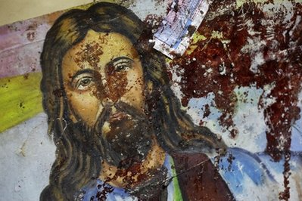
blood smeared on a Copt picture

"After the conquests the Christian's of North Africa disappeared."
("Islam: past, present", p. 219+)

By the 8th c. after conquering to Syria and Spain jihad was not accepted by the general community anymore since it would have turned into a costly and endless holy war. But now the captured slaves outnumbered the "converts" dropping the price of slaves to practically nothing:

see "Islam will Conquer", pg. , "Age of Faith", pg. 194, ("Islam: past, present", pg. 218), see, Ency. of Religion, "Islam in N. Africa", pg. 4580, "Great Arab Conquests", pg. 105

"Muslim leaders banned conversion to Islam lest the revenue fall."
("Islamic Conceptions of Holy Wars", Watt, 1974), see also "Evolution of God", p. 386

"The Arabs moved from a polytheistic mythology to a hero-based monotheism... There are two essential myths: the passing to Mohammed by Allah of the Koran, making him literally God's messenger and his Night Journey to the 7th heaven [from Jerusalem]."

("Jealous Gods, Chosen People: mythology of the Middle East", Leeming, '04, pg. 120)

In the 9th c. Italy and Sicily, a generation of Italians lived in fear. In 884, the Saracen's burned the great monastery Monte Cassino to the ground. Later the Nazis in WW2 did the same. Finally fed up with the medieval fatalism of "God's Will", the peasant Christians, combined forces of the pope, Greek and German emperors along with the Italians, defeated the Saracens in Garigliano.

("Age of Faith", pg. 290), for more sources see al-Baladhuri's "Book of Conquest's", 9th c.

9th Century

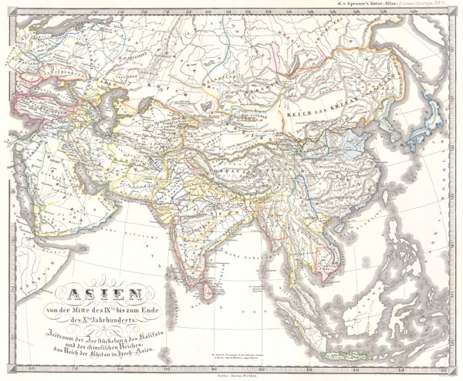

"In the 10th c. think 'marauding nomads' rather than fanatical Muslim."
("The Hindus: an alternative history", Doniger, '09, pg. 455)

"If the people of this religion are asked about the proof for the soundness of their religion, they flare up, get angry and spill the blood of whomever confronts them with this question. They forbid rational speculation, and strive to kill their adversaries. This is why truth became silenced and concealed.”
– Zakariya Razi (Rhazes), Persian chemist, philosopher and physician, 865 – 925AD.

In the 9th -13th c. Arab armies got the itch again and headed northeast into India and the Sind region. These raids depopulated the area, destroyed the culture and impoverished the survivors for a period of 500 years:

"Muslims have slaughtered million's of Hindu's in Bangladesh, Kashmir and India."
("Onward Muslim Soldiers: how jihad still threatens America and the West", Spencer, '03, pg. 183), see also, "The Legacy of Jihad: Islamic holy war & the fate of non-Muslims", Bostom, ed., 2010

An Indian point of view:

"Muslim's were seen as marginal, negative and destructive. Inferiors with no respect for dharma [paths of righteousness]...They massacred the people and plundered many monuments, at one point carting away 1,400 camel loads of treasure... There is no evidence of Indians appreciating them; and their peculiar nature of their mission--to impose a new monotheistic orthodoxy by military conquest and political domination. This was alien to Indian tradition."
("India: a history", Keay, 2000, pg. 188-209)

To the conquering Muslims this was sadistically called 'God's pleasure'. Why the Indians lost the battle:

"The Indian's were undisciplined and old-fashion in their tactics and were nothing against a well-armed cavalry and archers. The Hindu's died because of the Muslims own sense of superiority was backed by a fighting creed, a disciplined army and a crusading purpose. After 1200 AD, northern India was under Muslim rule."

("History of India: earliest times to the present", Edwardes, 1961, pg. 103)

"The Islamic conquest of India is probably the bloodiest story in history.”
Will Durant, American writer, historian, and philosopher

In all probability the later "peaceful" verses in the Koran were now inserted as expansion was over until the later Turks in the 1700's:

"Be good to your parents, orphans, the helpless, near and far neighbors, the travelers in need and the slaves you own. Allah does not love those who are arrogant and boastful". 4:36

"Show forgiveness, enjoin good and avoid the ignorant." 7:199

In Baghdad between 900-1100 AD, Islam even turned metaphysical and philosophical for a while. To some its texts were outdated and untrue so a few theorists and philosophers thought outside the box. Supposedly these were the most enlightened people in the then known world by helping to advance math and astronomy. However, some historians have disagreed with this notion claiming the overall Jewish influence in Baghdad instead.
Regardless, for roughly 150 years Muslims tried to espouse the 'inner jihad' or spiritual struggle illuminated by the metaphysical Ghazali (1058-1128) and others. But a few Saracen's thought that Islam "didn't make sense" but were afraid of speaking out:

("Saracen Philosopher's Secretly Deride Islam", Medieval Encounters 8, #2, 2003),

"[The philosopher's]...tried to find truth independent of the Koran."
("Islam: past, present", pg. 259-76), see also, "Islam in Retrospect", pg. 391

In Spain, the Muslims integrated with their society until they were later kicked out by the Crusader's from France in 1050AD. But even as late as the 12th c. there was still no proof of their "Prophet" in the Bible anywhere:

"The Muslims could not find a single proof in the entire Bible, not a reference or positive allusion to their prophet." Maimonides, Jewish theologian

(Epistle to Yemen, in Bostom, "Legacy of Islamic Anti-semitism")

Like I've maintained, the claims from the Koran are false and misleading.

1100

At the time the caliphate moved to Baghdad which became the center of Islam. Philosopher's like Avicenna and Averroes had their metaphysical theories overturned by the more conservative jurists. From there Islam has regressed into the literalism we see now:

"Islam has remained largely closed to the new [Western] shift towards the individual, towards personal freedom, towards nature, indeed towards the worldliness [normalizing] of the world."
("Islam: past, present", pg. 383)

Sira's or Bio

The sira's are the ancient bio's of Mohammed ("peace be upon him!") first written by Ibn Ishaq about 100 years after Mohammed (Sirat Rasul Allah, "bio of the messenger of God"). The originals were lost (!) and Ibn Hisham in the 9th c. started up again. But given the time gap most scholars are dubious about their reliability since even Ishaq himself commented, "it is alleged". Ordinarily this would be no problem, except today they are used by jihadi's as fact and rational for terror for what the Prophet supposedly did or said:

("Interpreting the Koran: guide for the uninitiated", Bennett, '10, pg. 21),
("Probing the Jihadi Mindset", Psychologist Sohail Abbas, PhD, 2007)

"The bio's are based on oral narrations, traditional stories, genealogy, poetry, sagas and myths."
("Mecca", pg. 13)

Even a devout Muslim has trouble with them:

"The Prophetic Tradition were compiled over 200-300 years and are unreliable... They contain countless instances of glorification of violence, including graphic descriptions of what Muslims out to do with their enemies and so-called enemies of God."
("Islam in Retrospect", pg. 343)

"Jihadist mythology..."

("Knowing Islam", pg. 169)

"The 'speeches' [of Mohammed] we view as fictitious from beginning to end...They are full of contradictions, confusions and inconsistencies."

("The Early Arabic Historical Tradition: source critical study", North/Conrad, 1994, pg. 87), ("Slaves on Horses", Patricia Crone, 1980, pg. 7)

Sharia ("way to the watering hole") 10th c.

"Today many Muslims will argue passionately that civilians, including women and children, are acceptable targets in a war imposed on Muslims."
("Journey into Islam", pg. 168)

"The [liberal] Muslim's who contest sharia law are often charged with 'selling out to the West.'"
("How to read the Quran", law/authority)
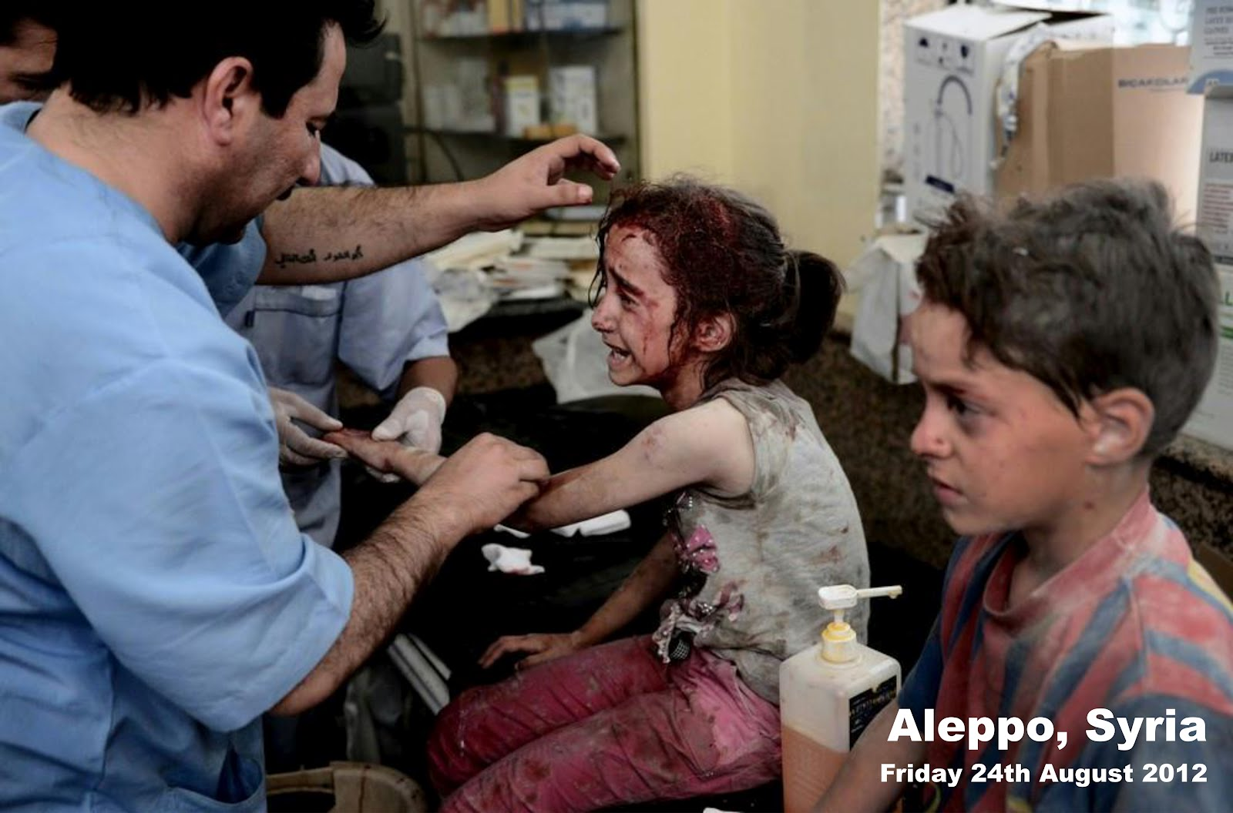

What drives the West absolutely crazy is sharia or fundamental jurisprudence. The sharia were extracted from the Koran and put into laws and political theory around the 9th c. Historically, the earlier sharia in Baghdad were the least strict and the most liberal as it allowed interpretation outside of the Koran. Sharia is last in line as far as importance:

"The same fiqh [law] that earlier strove to design general principles and mechanics for change is living proof that Islam is a secular and not a legal system."
("Islam in Retrospect", pg. 319)

To the West, Middle East sharia logic is outrageous, unacceptable and can be immoral yet we don't or can't do anything to change it. This is one reason how bin Laden rose from obscurity:
("Sword of the Prophet", pg. 146)

"The shari'a has glorified that concept of jihad to the point of placing it among the pillars of Islam." ("Al-Islam Wa-l-Mujtama' al- 'Asri", Saleh, pg. 92)

"Islam, the sharia, and by extension jihadist ideology, can never be altered. The world must be changed to reflect the truth of Islam... Mankind is not allowed to question the Koran."
("Knowing the Enemy: jihadist ideology and the war on terror", Haback, '06, p. 47+)

Of course many modern and educated Muslims in the ME ignore the thousands and thousands of sharia laws. This is currently the 'swing state' of affairs in moderate states like Turkey and Jordan now:
("Women, Muslim Society and Islam", Faruqi, pg. 14)

"The Sharia came to dominate Muslim life. The door was closed against further borrowings from the outside [ijtihad]. Philosophy was seen as a danger to Faith... Science was viewed as 'atheism.'"
("A History of Medieval Islam", Saunders, 1972, pg. 197)

Again, we shouldn't be too outraged here since medieval Christianity did exactly the same thing with its legalistic views fromthe New Testament for over a thousand years up to the late Reformation. No doubt, religion has a huge and basically negative power over people:

"To the jihadi, the very concept of international law is contrary to sharia and they refuse to honor any agreements."
("Knowing the Enemy", pg. 126)

An Iranian scholar:

"Sharia can become a political tool, deprived of detail... When Muslims speak of 'peace' they mean a society under Sharia law. Sharia is their liberation of mankind."
("How to Read the Quran", pg. 92), ("Onward Muslim Soldiers", pg. 237)

Worldwide we see its draconian laws implanted in Iraq, Arabia, Malaysia, Sudan, Syria, Nigeria, Philippines and parts of Thailand now. Not long ago it was Algeria, Lebanon and Chechnya. Unfortunately this will not change anytime soon:

"Sharia and fiqh are essentially the same. Each is subject to the same risks of human error, ideological, political bias and economic interests."
("Islam and the Secular State: negotiating the future of sharia", An-Naim, '08, pg. 35)

More importantly for the West to realize is the Middle East is in chaos precisely because of sharia; not the other way around:

"Muslim woman are eager for freedom and self-confidence but are not sure how much freedom they can claim without violating Shari'a rules and limits... Sharia is not and was never intended to be a legal system."
("Islam in Retrospect", pg. 321, 386)

The West is adamant about our civil rights, but even in a police state like China most of its people are now treated fairly and who can have a court hearing. But in the ME civil rights are through sharia courts, like in Egypt. Where people democratically voted into office are suddenly tossed out and thrown in jail. Today the West should realize that sharia is not a "religious rights" issue anymore but rather a human rights issue and Islam directly is to blame:

"The historical version of the Sharia is incapable of preserving fundamental human rights today." Sudanese Muslim legal scholar Ahmed an-Na'im
(sourced from "Islam: past, present", pg. 573)

Human Rights

"Islam can engage in mechanized slaughter of its own citizens.”
("In Pursuit of Justice: jurisprudence of Human Rights in Islam", Hathout, PhD, '06)

When the Koran was written the thought of human rights was never imagined; although it does have instances of what we might consider "fair play". But in most Muslim countries, the Koran along with sharia, can trump even their government! For instance, Egypt tossed out its democratically-elected leader and now wants sharia implemented instead:

"Human rights ratings for the Middle East and North Africa were the worst in the world."
(Freedom House, "Freedom in the World 2015: Freedom Declines for 9th Year")

While to the majority of Muslims today the 7th c. Koran can never be changed one iota or else they might lose their "faith"! How lame is that? So in the meantime the barbarity continues:

"Innovation of faith is one of the gravest sins in Islam, on par with murder and apostasy."
("Heretic", pg. 56)

'Violent acts of extremism cannot be divorced from its religious doctrine.' Ali
("Heretic", liner)

In other words, as long as the Koran is around there will always be violent acts where ever there are Muslims. This is unavoidable and everyone is at risk:

"The most violent Medina Muslims [where Mohammed waged tribal wars] can find a holy writ justification for everything they do." Ali
("Heretic", pg. 93)

While researching this ebook I came across a somewhat gruesome video filmed in northern Iraq. Two big-rig truck drivers, possibly Shi'a, were stopped by ISIS and put on the ground. One remarked, "We want to live". Then they shot them point blank. One victim crawled in shock and was shot again:

"Takfir ideology believes Islam must be purified of 'Muslim impersonators'. Thus militant Muslim groups who murder Muslims indiscriminately."

("Inside the Middle East: making sense of the most dangerous and complicated region on earth", Melamed, '16, pg. 46)

Why Islam May Be a Cult

"Defeatism is rife through the Muslim world. The lurid conspiracy theories about international affairs have a great currency among Muslims, even with educated members of society.”
("In Pursuit of Justice", pg. 375)

Here in the U.S. the racist “alt-right” has been declared a cult by the left. Well, if it is then it should be obvious that Islam is also a cult:

“There is a rhetoric and a ritual script. They have created an esoteric private language.”

(“Make no mistake about it: the alt-right is a cult and this is how its members lure people in”, The Independent, O' shaughnessy, 9/10, 17)

What is a cult?

Universal definition: Any group with a pyramid-type authority and leadership structure with all teaching and guidance coming from the person at the Top.
("Freedom in Christ", Australia, Jan Groenveld, 1985)

In general, cults can be contrary to orthodoxy. More importantly, cults are not a philosophy. Cults have leaders who others blindly follow and they can be either living or dead. In our friend Mohammed's case he would legitimately be called a cult leader in that he alone started the religion and commanded that others follow him:

"A cult of personality is similar to hero worship and propaganda usually by the state, especially in totalitarian states."
(Lectures on 20th c. Europe, "Stalin and the Cult of Personality", Kreiss, 2000)

"The cult group displays excessively zealous and unquestioning commitment to its leader and (whether alive or dead) regards his belief system, ideology, and practices as the Truth, as law."
("Why Islam is a Cult", Bob Smith)

Cults usually have conformity and a core belief:

"Conformity to a group's behavioral norm is perceived by members for maintaining their well-being".
("Cults: faith, healing and coercion", pg. 37)

Reasons

1). A cult is a religious group with extreme beliefs and practices. Beliefs that are often contrary to science and logic but they are believed as "obvious truth" by the cult members. Of course there are both good and bad cults. Mormonism and Jehovah's Witnesses have been labeled "cults" by others but regardless, the people are very friendly, pleasant to be around and certainly harmless:

"Jihadi's believe they must rid the earth of democracy, liberalism, human rights, personal freedom and international law. They don't believe this can be played out peacefully."
("Knowing the Enemy", pg. 161+)

"Damaging cults often resort to very complex deceptions."
("Straight Talk", pg. 57)

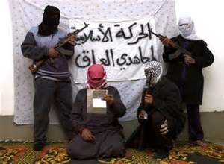
Do these people look religious? They are in the cult of Mohammed

2). Cults use manipulative methods to bend the minds of followers. The leadership dictates, sometimes in great detail, how members should think, act, and feel. These methods ranged from threat of hellfire to promises of paradise. This quite accurately describes Islam as a totalitarian ideology with a façade of religion:

"Most people believe that cult members are mentally unbalanced. That is a myth."
("Cults in our midst", Singer, PhD, '95, liner)

"Many dominant religious groups began as cults. Some of these groups die out when their leader dies. Others return to their cult characteristics well after the death of their leader... Later the cult then becomes accepted by society as a religion."
("Straight Talk", pg. 12)

"Cultists perceive the religious views as true. Its inflexible standards as concrete."
Ed Levine, PhD
(quoted from "Cults & Consequences", 2-7)

3). Cults usually adore its leaders. The leader is not accountable to any authorities. Others are not allowed to criticize the leader, the doctrine, the organization or anything critical of the cult. The group is elitist, claiming a special exalted status for itself. The leader is considered a Messiah, an avatar, on a special mission to save humanity. Its leader, Muhammad, is proclaimed to be the perfect man whose example every Muslim should follow. Everything he supposedly did or expounded is considered perfect and cannot be challenged or changed upon threat of death. The supremacy and arrogance of the concept of Muhammad is that he is supposedly the last prophet – there can be no more prophets:

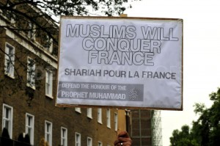

"Allah was well pleased with the believers when they swore allegiance to you [Mohammed] under the tree. So He rewarded them with a speedy victory and many spoils which they will soon acquire!" 4:18

For example, in a Youtube video a few years back Muslims in Sweden go ballistic over an R-rated film in a theatre. The police show up and they scream at them daring them to pull out their guns. Loud, self-righteous chants ring out. Not about Allah, God or religion but rather "Mo-ham-med!!"
(planetofworld, June 5, '13)

4). Islam considers anyone who criticizes or tries to change Islam guilty of blasphemy or "unbelief". Unbelief is a capital crime under sharia law. As a result any Muslim who criticizes Islam has to worry about retaliation by a devout Muslim(s):

"The 'Sword' verses carry the highest authority in all discussions of war... and have come to represent classic post-quranic thinking serving as proof texts... Those who do not share this Quranic message are charged with varying levels of unbelief, ingratitude and denial."
("How to Read the Koran", pg.), ("Wahhbi Islam", pg. 231+)

5). Group has a polarized "us vs. them" mentality. This can cause conflict with the wider society. As an example today, in Western Europe and Russian where Muslims are a minority they play the "victim card" as an "oppressed people". Quite often others feel sorry for their plight and even join their ranks. The exact same thing happened at a rally recently in the U.S. where a 20-something white guy holds a poster reading, “I am a Muslim”. He most likely knows nothing about the religion:

"Do not be deceived by the free movement of the unbelievers in this land [historically Christians, Jews, Persians, Indian's]. Their ultimate home shall be hell, an evil sort." 3:196

An Egyptian radical:

'Through tawhid [monotheism] Muslims can only allow one religion: all others are not just false, they are described as wicked perversions of the truth. Followers must be subdued.' Qutb
(paraphrased from, "In the Shade of the Quran")

6). Muslims are encouraged to commit violence in the name of Islam. The Koran, Hadith, and Sira's (bio) are filled with statements which encourage devout Muslims to commit violence in the name of Islam:

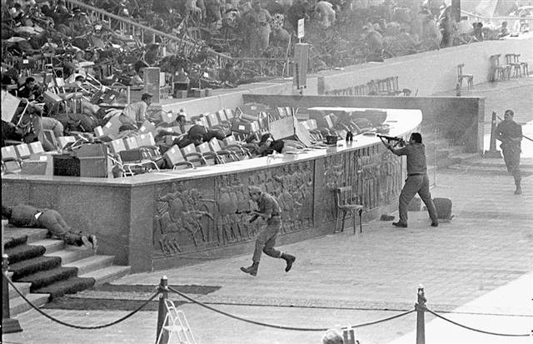

Egyptian Pres. Anwar Sadat murdered by Islamists, 1981

"I am Khalid al Islambuli! I have killed Pharaoh, I don't fear death!"
("The Prophet and the Pharaoh: Muslim extremism in Egypt", 1985, p. 192)

Of course, Islam would not be complete without sharia dragging along behind it, which is why Sadat and other leaders have been killed. Another recent example was the overthrow and murder of Moammar Kadafi (compliments of Hilary and NATO!) but who was basically a friend of the West and who sold Europe oil:

"A ruler who does not apply parts of the Sharia denies its binding character and is an apostate."
("Jihad in Classical & Modern Islam", Peters, '96, pg. 166)

"[In the Middle East] the most flagrant violations of civil rights, political freedom and even human decency are disregarded or glossed over. Crimes against humanity, which elsewhere would provoke outrage, are deemed normal and even acceptable. The underlying assumption [politically] is that Muslims are incapable of manning a democratic society and have neither the concern nor capacity for human decency... They are instructed not to turn the other cheek."
("Crisis of Islam", p. 105, 143)

7). Group teaches or implies that its supposedly exalted ends justify whatever means it deems necessary. For example, when Islam is defamed in any way, Muslims should violently defend it, even in a cartoon! But Muslims can and should hypocritically defame Jews and Christians in Muslim newspapers, the internet and television:

"[To outsiders] cult members appear strange, often disturbing and even frightening."

("Sects, 'cults' and alternative religions: a world survey", Barrett, '96, liner)

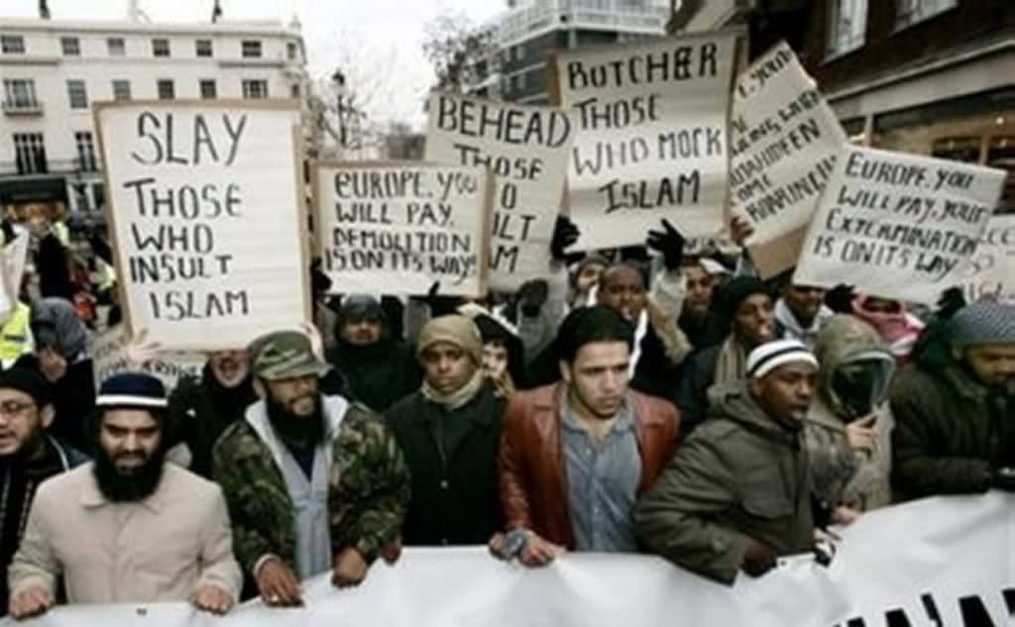
France

8). Members are trained to reject and not believe criticism of the cult as "lies from Satan": 7:27

"He who turns away from the Compassionate [Allah's jihad] We assign a shaitan [devil] for him who becomes his intimate companion." 43:36

Muslims will never change the Koran to fit into Western society. As mentioned, the doctrine is absolutist and the ideology internalized as "the Truth":

"When one joins a charismatic group [Islam] one gives up the opportunity for independent decision making and complies with the groups norms."
("Cults: faith, healing, coercion", pg. 87)

"As for the unbelievers [pagan tribes, Christians, Jews, Persians, Indians] they will not cease fighting until they succeed in turning you back from your religion! If any turns back his deeds will become void in this life and in the hereafter! He will be the inmate of the hellfire!" 2: 217-8

9). Members are encouraged or required to live and/or socialize only with other cult members. The most loyal members (“true believers”) feel there can be no life outside the context of the group. Outsiders are viewed as aliens—this includes the West (and how we got 9/11):

"Do not believe anyone except the one who follows your own religion!" 3:73

"[Cult] family members draw together and limit access of outsiders."
("Cults", pg. 28)

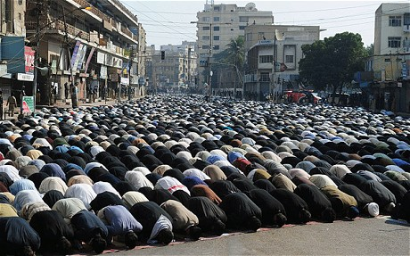

Muslims praying in the middle of the street, 3-5 times a day, Pakistan.

10). Disciplinary action is administered by group leaders which may involve "excommunication" for such things as questioning organization policy or doctrine:

"Religious cults may turn to violence against their own members under a deranged leader."
("Cults", pg. 119)

As you will read this exactly happened during the Iran Revolution, 1979:

"But the criminal's [unbelievers] will abide in the punishment of hell. We did not wrong them but they wronged themselves! We [Allah] have brought you the truth but most of you hate the truth! If they have devised a plan to ruin you [O Mohammed] then surely We too shall devise a plan to ruin them!" 43:74+

11). Subservience to the leader or group requires members to cut ties with family and friends. A Muslim is not supposed to be friends with non-Muslims. Muslims consider all non-Muslims and non-Muslim culture useless and see their goal to make the whole world Muslim. Everything before Islam is jahiliyya or ignorance, is of no value and should be destroyed. In the opposite spectrum, Muslims in non-Muslim countries tend to stay together and form ghettos:

"A common observation is the animosity cult's illicit from outsiders [non- Muslims]."
("Cults", pg. 98)

A Post-Mohammed verse:

"O believers, [Egypt/Syria] do not make your protecting friends, those of the Book [Christians, Jews] who have made your religion a mockery and pastime. They are devoid of understanding... The fact is they are rebellious transgressors!" 5:57+

12). Members are instilled with a deep fear about ever leaving the organization and anyone who does depart is of the devil and sometimes severely punished. Don't let any Muslim try to deny this fact by quoting the Islamic phrase, "there is no compulsion in religion" (ch. 2). All Muslims know the doctrine of "abrogation" which negates this phrase. Muslims use this when they are trying to deceive non-Muslims:

"Cults require conformity. Those who fail to demonstrate proper allegiance, who raise too many questions, disobey the rules or openly rebel are punished."
("Cults & Consequences", ch. 1)

This is what millions of Muslims complain about yet still reluctantly obey:

"Groups use mind control and life becomes one rule after another. Communication flows from the Top down. Cult members are taught to obey leaders without thinking. The group is the final judge of what is good and evil."
("Straight Talk about Cults", pg. 90)

A Muslim extremist's concurs:

"If anyone adopts the attitude of resistance [to Islam] then it would be obligatory on Islam to fight him until he is killed or declares his loyalty and submission." Egyptian theorist Sayyed Qutb
("Milestones", Qutb, 1964, p. 113)

13). It is forbidden to kill a Muslim (except for a just cause). It is not forbidden to kill an infidel. This causes a bond between Muslims and fear in non-Muslims:
7:33

'[In Maliki law] killing civilians was not even blame-worthy.'
see, "The Reliance of the Traveler", al-Misri, ch. 9)

"Clerics have repeatedly declared takfir (unbelief) on entire groups of Muslims."

(Muhammed Omar, "Fatwa against those who ally with the disbelievers against Muslims", MEMRI.org, Sept. 11, '03)

These groups would be labeled "enemies of God." For example, in the '90's the Algerian civil war lasted 10 years straight. Jihadist's under GIA and other Salafist groups murdered at least 100,000 of their citizens who were labeled "infidels" according to these insiders. This was considered ok by the clerics because the reigning government refused to step down and "submit to God" or sharia:

see, "The Great War for Civilization", Fisk, '07, "Knowing the Enemy", pg. 156

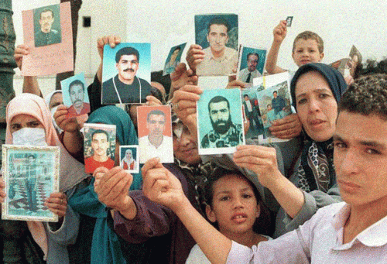
Missing from the Algerian war

14). Islam must always be defended. This idea is a primary linchpin that gives justification for war with almost anybody. Islamic writings also teach the use of pretext to start wars as what happened in Lebanon under Lebanese National Resistance Front (Jammoul) against the Christian majority:

"A deluded leader who is prone towards paranoia is likely to incite members to violence."
("Cults: faith, healing, coercion", pg. 195)



Lebanon's "civil war", 1975-1990. see, "Onward Muslim Soldiers", pg. 248, or see Palestinians/Israel for more up to date examples:

"The masses are taught to react violently towards anyone who questions or criticizes Allah, Mohammed or his teachings."
("Because They Hate", p. 109)

"Feelings of paranoia are encouraged by cult leaders in order to bind members of the group more closely... Some cult members develop irrational fears of anything that reminds them of the outside world."
("Straight Talk", pg. 113)

15). Islam has explicit double standards: one standard for Muslims and a different standard for non-Muslims. This always gives the advantage to Muslims and within a Muslim country, provides incentives to convert. There is no right and wrong in Islam; there is no golden rule in Islam! What advances Islam is good; what impedes the advance of Islam is bad. Islam must be free to spread around the world but other religions cannot try to spread their religion:

"O people of the Book, [Jews/Christians] now Our Rasool [Mohammed] has come to you to reveal what you have concealed from the Holy Book...The fact is most of you are rebellious transgressors!" 5:16, 58

"O Prophet! Make Jihad against the unbelievers and hypocrites and be harsh against them! Hell shall be their home; and it is the worst of all homes! Even if you ask forgiveness 70 times, Allah is not going to forgive: because they have disbelieved Allah and His Rasool [Mohammed]." 9:80

16). Cults can have a belief in apocalypse and Dooms Day. This is a warning to members who may leave:

"When the sun ceases to shine, when the stars lose their luster, when the mountains are blown away, when the oceans are set ablaze...when heaven is stripped away, then each soul shall know." 81:

17). The Qur'an counsels the use of deceit when dealing with infidels. According to one of the hadiths, Muhammad instructed one of his followers to lie if he had to. The principle was clear: 'If it helps Islam it's okay to deceive non-Muslims'. This is taqiyya. It has been used historically and is still used: Islamic leaders saying one thing in English for the Western press and saying something entirely different in Arabic for their Muslim audience. Deceiving Westerners is totally acceptable:

"Cults have 'grey' areas."
("Cults & Consequences")

18). Islam seems to fit the ICSA criteria for a cult. Since Allah is deemed to be unknowable, Islam seems to better fit as the cult of Muhammad. Muslims refer to Allah but they seem to have deified Muhammad. Everything is about Muhammad. One strong indication of this is that the Sacred Law is not the law of Allah but the Sacred Law of Muhammad. Throughout the Qur’an, it is “Allah and his Messenger,” but sometimes it is just the Messenger:

"But Allah gives authority to His Rasool's [Mohammed] over who He pleases, for Allah has power over all things." 59:6

(source: International Cultic Studies Assoc., "Five Reasons why Islam is a cult", Bob Smith)

Other Cult Figures in Recent History

Adolf Hitler

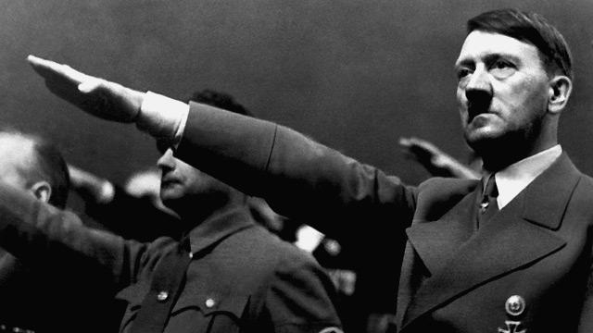

"Nazism is a religious phenomenon in its own right and appeals to the same issues and emotions that religion does: faith, ultimate meaning and redemption."

("Heaven & Earth: varieties of the Millennial Experience", Landes, '10)

No one doubts that Hitler was a huge cult figure but today preaching a Nazi ideology in Germany means three years jail time! Might we see that from preaching the cult of Mohammed? Don't think so. Regardless, both ingeniously used mass control over their victims:
see, "Germany's Nazi Exception", Der Speigel, Nov. 19, '09

"Hitler viewed the nation [Germany] as supernatural, with himself as a god and prophetic high priest that he felt himself to be... He acted as "Supreme Judge of the Nation" deciding the destinies of people."
("The Hitler I Knew: memories of the Third Reich's Press Chief", Otto Dietrich, '10, p. 5+)

"Cults are settings for the classic symbiosis of sadistic and masochistic personalities. The domineering personalities of cult leader enable them to capture and control the minds of converts." Ed Levine, PhD
(sourced from "Cults & Consequences", 3-17)

Radical Islam and Nazism on the same page? Some seem to think so:

"Jihadist theories are actually very close to Nazism and Hitler's Mein Kampt
["my Fatherland"]. 'Mein Kampt' inspired barbarism and genocide, mass rallies and indoctrinations..."
("Knowing the Enemy", intro, pg. 101), see also, "Create Your Own Religion", p. 93

"Islam draws on [both] communism and fascism... Hitler imagined an endless struggle of the 'superior' to fend off the 'inferior'... Both Soviet and Nazi regimes gained followers from idealist's and the young. Such people virtually worshipped their leaders."
("World Turned Upside Down", pg. 234), ("Lenin, Stalin & Hitler", pg. 16-7)

"Islam has found its niche of 'modernity' in being like 20th c. totalitarian ideologues. The all-pervasive lack of freedom that is the hallmark of the Muslim world."
("Sword of the Prophet", pg. 207)

Muslim extremists still want a one-nation under Allah. The problem is there is no one leader under Islam, no pope to control things. This is why Islam is out of control:

"Islamist's make use of fascism as a doctrine of bloody nihilism. Like Nazism, Islam promotes a subordination of the individual to the collective leadership principle."
("Jihad & Jew Hatred: Islamism, Nazism and the Roots of 9/11", Kuntzel, (Ger.), '07) , see also "Birth of Fascist Idolatry", Sternhell, 1994, pg. 1-7)

"This unrealistic, transcendental idea of a nation was expressed in Hitler's Nuremberg speeches."
("The Hitler I Knew", pg. 5+)

Bashar Assad

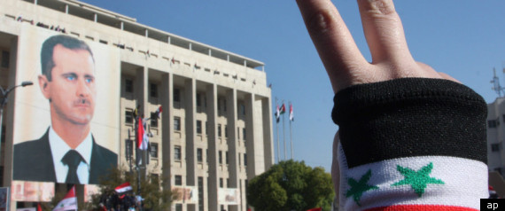

Assad is a member of the secular Baath Party, an Alawite Shi'a, and has a small cult status:

"Bashar al-Assad is not keen on the cult of personality and his dislike of his father’s fascination with statues implies that Assad is innately reprogramming Hafez’ personality cult of totalitarianism... The four-year conflict has produced a leadership that is sustained by a culture predicated on the supposed right to be violent and the right to kill. The harsher and more bloody the leader can be the more chances he will have to survive in power. Driven to the extreme, the leadership takes the form of a cult.
With people’s inability to participate in public sphere, or in functional political organizations, they find religious fundamentalism a way out... ISIS as a cult is not only a product of a barbaric war that has been brutalizing people throughout the last four years but is also a product of Assad’s cult of personality.”

("ISIS: the Product of Syria's Cult Culture?", Dr. Halla Diyab, Al Arabia News, Dec. 9, '14)

Chairman Mao

"Cultists are 'true believers' who upon accepting the status of their passive-submissive followers derive gratification from their subservience."
Ed Levine, PhD
(sourced from "Cults & Consequences", 3-17)

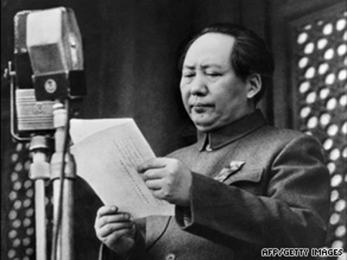

"What is wrong with worship? The truth is in our hands...Each group must worship its leader. This is the correct cult of personality." Mao
(speech on March 10, 1958 at Chengdu, Gansu, 91-18-495, p. 211)

Like the U.S.S.R., China was a secret society off limits to the West for about 40 years and no press was allowed. Not so surprisingly the Middle East (especially Saudi Arabia) still has this lack of transparency, fearful that an outsider will "expose" their way of life:

"We must have blind faith in the Chairman!" Mao's henchman
(Dayuejin, Li, vol. 2, p. 288)

"Mao's Great Leap Forward killed at least 45 million peasants. It was an experiment in catastrophe."
("Mao's Great Famine: 1958-1962, Dikotter, '10, liner)

Stalin

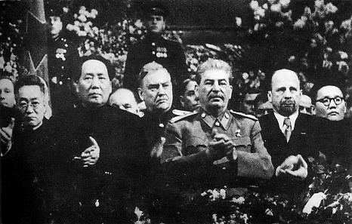

Mao at Stalin's 70th Birthday Party, 1949

"Stalin prepared his own remedy for dissidence and free thought... He understood the worst in human nature and motivated others in submission to their psychopathic master to kill in the ensuing 'Great Terror.'"

("Stalin and his Hangmen: the tyrant and those who killed for him", Rayfield, '04, p. 293)

"Lenin, Stalin and Hitler's pursuit of utopian--and dreadfully flawed--ideal led only to a dystopian nightmare."
("Lenin, Stalin & Hitler: age of social catastrophe", Gellately, '07, liner)

In reading the Koran, the writer comes across as paranoiac in nearly every sura:

"Why 'it' happened can be explained by Stalin's paranoiac war of all against all."
("Stalinism as a Way of Life: a narrative in documents", Siegelbaum/Sokolov, 2000, p. 23)

"It is not in the habit of authoritarian personalities to reveal their true motives."

Ed Levine, PhD
(sourced from "Cults & Consequences", 3-17)

Jim Jones

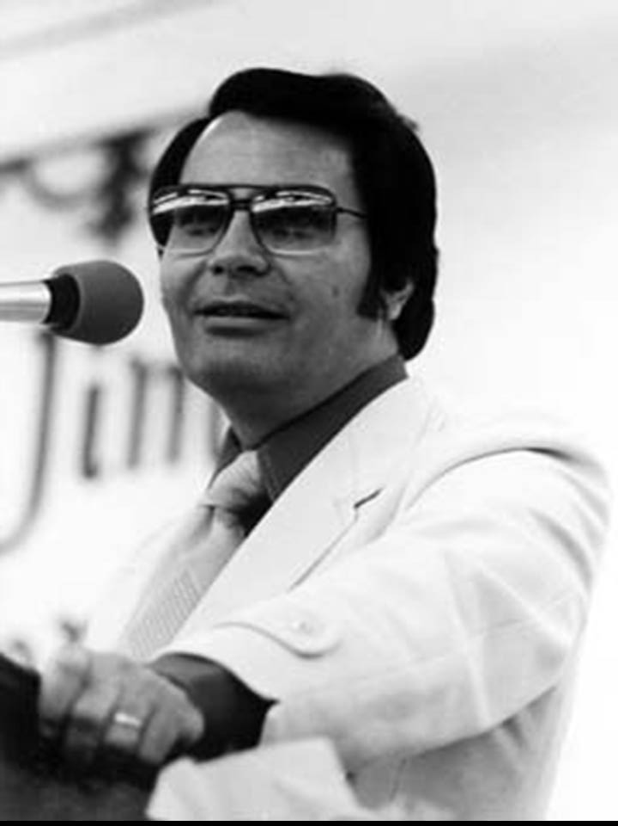

"[Cult] leaders become holy terrorists when they get power-hungry, greedy or violent in addition to believing that they are 'God's exclusive messenger on earth.'"
("Straight Talk about Cults", Kay Porterfield, M.A., '95, pg. 7)

Suave, debonair, handsome, Jim Jones was best known as the cult leader of the "Peoples Temple" who led more than 900 followers in a mass suicide via cyanide-known as the Jonestown Massacre (1978). Early on the media got wind of the cult and sent an NBC camera crew including several very brave Congressmen (totally unthinkable now). Shortly afterwards the cult members, not wanting the exposure, shot 5 of the group to death on an airstrip in Guyana, South America. The parallels to politically-militant Islam were eerily similar...

Nobody in the states had ever heard of Jim Jones until I witnessed a photo on the front page of the L.A. Times where 400 people in a cult had killed themselves in South America. This tragic figure was later revised upward.

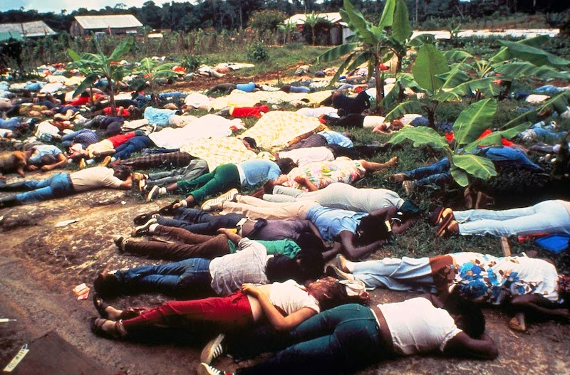

David Koresh

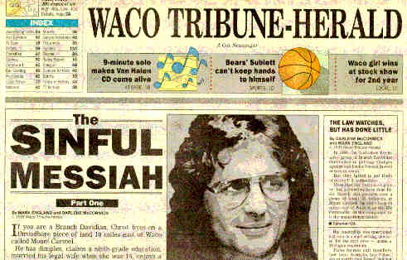

"In 1983 Koresh proclaimed the gift of prophecy..."
("The Devil's Party", Wilson, 2000)

Another rather infamous cult leader was David Koresh who was believed to be "God incarnate" by his fellow "Davidians". The Davidian's followed him for years with his apocalyptic views of the Bible to their deaths--no different than millions of Muslims regarding Mohammed today...
Most know the story of the Branch Davidians who were members of a religious group and were very anti-government. But what was shocking then was the engulfing fire of the building with children inside. That cults would rather perish with their beliefs than change their ways. Seventy nine (79) people perished in the blaze along with 22 kids:

(Dallas Morning News, "Davidian Denies that Sect fired first", 6/29/2000)

"In thought reform the self-concept is de-stabilized." Margaret Singer, PhD

(sourced from "Straight Talk") see also, "Thought Reform and the Psychology of Totalism", Lifton, MD, 1989

What Dr. Singer means is the cult doctrine is the leader now. Followers can "turn off" themselves and their thoughts just like Islam also commands.

Ayatollah Khomeni

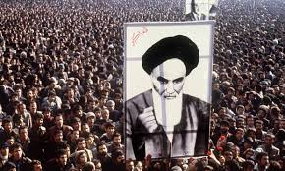

"The Quran is our constitution." Ayatollah Khomeimi
("Islamic Government" #31, 8/18,1988)

I remember the Iranian Revolution quite well! And as fate would have it at the time I had an Iranian roommate who had left the country months prior. Such irony I thought as I'm living next to true history!
In 1979, Iran switched its leadership by ditching the Shah, although not every Shiite in Iran wanted a strict theocracy including my Shi'a roomie who couldn't stand the Ayatollah. But once in power, and by heeding directly to the Koran for its new theocracy, the Ayatollah devolved the state to mass murder and the torture of 100's of thousands of Iranian's--a fact often ignored by U.S. press even now. Thousand's were imprisoned in Evin by the Revolutionary Guard under his direct orders even including even teenage girls who were hung at dawn as "enemies of the state":
(NY Times Magazine, Feb. 12, 1984, pg. 194)

"Because it dealt so mercilessly with its enemies Khomeini's revolution was irreversible... In the summer of '88 at least 10,000 inmates were hanged."
("War for Civilization", pg. 172, 274)

"Khomeini introduced the Marxist concept of a world divided into oppressors and oppressed. Iran established a totalitarian apparatus including 'moral's police' and a ministry of intel as watchdogs for Islamic conformity. By 1980 Khomeini purged all traces of Western influence from its schools."
("The Mind of Jihad", Muraviec, '08, pg. 235)

In the decade war with Iraq (which the U.S. reluctantly sided with Saddam as the lesser of two evils) Khomeini as iman led 1000's of boys as young as 11-12 to the front lines as "martyr's for Islam". The parents never objected.

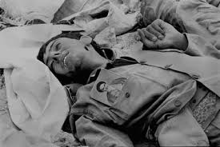
basiji, front line, 1981

Ironically, even a genocidal murderer like Saddam himself, who gassed the Kurds in northern Iraq from helicopters, was outraged by the child soldiers:

"Khomeini has become a murderer in his own country..." Saddam in interview with author
("The Great War for Civilization", Fisk, '08, pg. 159, 179-258)

After the 10 yr. war with Iraq, the Iranian Revolution gradually "ran out of steam". Fortunately for us now the Iranian's now have rebelled from their initially strict interpretation of Islam preferring mutashabin or a flexible/allegorical view.
While even some women have tossed their head scarf's preferring Western garb:

"Shi'a's are 'blindly infatuated with the West'...They never wanted to identify their self with the majority Muslim umma."

("Journey into Islam", crisis of globalization", Ahmed, '07, pg. 45), ("No god but God", pg. 170)

Unfortunately today most other Sunni or mainstream Muslims view them as devils and kuffar over their allegorical views and want them dead and buried. Iran is still under strict persecution and is somehow forced into uneasy alliances with genocidal murderers like Assad who is from a Shi'a sect.

Saddam Hussein

"Islamic or Arab socialism includes the Baa'th party. This position was sympathetic to the Soviet world."

("Islam in the Modern World: challenged by the West, threatened by fundamentalism, keeping faith with tradition", Nasr, '10, pg. 35)

To the millions of Sunni in Iraq, "Uncle Saddam" was a cult hero par excellence and who followed his every whim. He lived in palaces, had billboards of himself everywhere while millions both north and south lived in squalor. Falling not far from the tree, one of his sons sadistically raped and killed young women just for pleasure. As a member of the secular Baath Party (like both the creepy Assad's) Saddam was more of a military guy and not a very good Muslim... As some know, Saddam tortured, killed and or executed perhaps 100,000 Kurds in northern Iraq and Shiites in southern Iraq--all with the blessings of Sunnis! Unfortunately for him (and the U.S.) he was also a scapegoat for starting 9/11...
see, "Great War for Civilization"

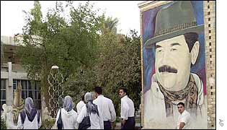

see also, "Great War for Civilization", pgs. 179-258

Jihadi's--past and present

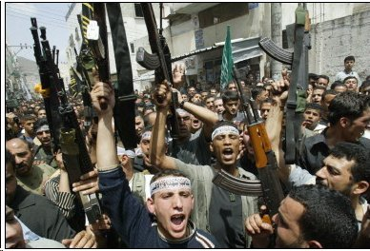

This pic could be anywhere in the ME: Palestine, Syria, Yemen, Libya, Iraq or Algeria:

"Jihadist's are fundamentalists."
("Knowing the Enemy", pg. 101)

Obviously most Muslim's (especially Shi'a) don't believe in jihad per se. But as noted, the Koran does seem to be more about jihad, fighting, believer vs. unbelievers and apostates than an inner spiritual code. Further worse extensions from the Koran are the hadith, sunna and sharia which jihadi's and local imams use to sort out for their own ends. This is happening now in Saudi Arabia, Syria, Afghanistan, Iraq and Yemen, Egypt and Nigeria as I write. That fact alone should make the religion an enemy and not a friend of the West and should be dealt with as an enemy of law and world order. The Koran:

"Fight them until there is no more disorder and Allah's supremacy [caliph's not Mohammed] is established." 2:190-3

"Whenever you encounter a force [against you] be firm and unshakable." 8:45

"Prescribed for you is fighting, though it be hateful. But it is better for you...God knows and you do not." 2:216

"The separation of religion and state contradict the way of Allah and permit what Allah has prohibited." Seleiman Greith, al-Queda

(quoted from Centre for Islamic Research & Studies, www.memri.org)

As members of a personality cult they "called" themselves to jihad:

'Jihad is the peak of Islam.' Saudi cleric Al-Ghaqawi
(MEMI.og, "Friday Sermons", Sept. 26, '02)

"Jihadi's are extremely selective about which verses they will listen to."

("Knowing the Enemy", pg. 43+), see also, "A Fundamental Question: al Tahir and the search for the Islamic Caliphate", Taji-Faronhi, '96, pg. 89-105, "Why I am not a Muslim"

Fortunately there is bright side for our U.S. military. In Syria there's a new jihadist phenomenon where militant groups once at swords point are coming together and fighting for a common goal: namely stomping out a mass-murderer like Assad and his government soldiers. Moderate Muslims from Syria, and around the world, are fighting side-by-side with al-Nusra/al Queda against Assad. This was unthinkable just a decade ago. The U.S. has tried to fund these "moderates" but has been burned by defections and lost weapons and now Russia has stepped in. But to the radicals, sharia over Syria is not a priority and getting Assad out is:

"It is a myth that terrorists are isolated, vulnerable young men with paranoid personality disorders." Dr. Silke, forensic psychologist

("Terrorists know what they are doing, They are not crazy, say researchers", Medical News Today. com, 7/11/04)

"The muhahedin are not 'highjacking' Islam; they are restoring it [back to the 7th c.]... The jihadi's central point is the ongoing war with falsehood. That it will continue until Islam has 'liberated' the entire world from darkness, tyranny and servitude to mere men... The Koran is a war not just against the West but also with in Islam itself." ("Onward Muslim Soldiers", pg. 228), ("Knowing the Enemy", pg. 121, 137+, 165), see also "Milestones", Qutb, "How to read the Quran", pg. 93

"The internet is the most successful means to enlist great numbers of youths from Arab and Islamic countries." Abu Musaab
("Fatah al-Islam", Daily Star Lebanon, 6/14/07)

The more Islam spreads the more people will be under its influence for both good and bad. We see this now with ISIS and their constant 'Allahu akbar's whenever they see death. As in San Bernardino, Paris and Belgium, Nigeria and Kenya, the West however, views these as sadistic acts:

"Islamic militancy will intensify... as jihad becomes associated with a divinely-ordained state of war."
("How to read the Quran", ch. 8), ("Sword of the Prophet", pg. 5)

"Unfortunately Muslims have glorified the sword as a symbol of justice..."
("Islam in Retrospect", pg. 342+)

Of course no one would really care about Islam at all if it weren't for the jihadist's and mosque's who rally to control others:

"For the jihadist's, this evil world has to be conquered for Islam or else destroyed, as exemplified by Mohammed's conquest's in the Koran... As far as the Islamists are concerned the individual has no status--except as a vehicle for God's will. Human reason is considered sac-religious by orthodox Muslim's... Combat is a requirement."

("World Turned Upside Down", pg. 139-47), ("Jihad in Classical and Modern Islam", pg. 164)

Ibn Taymiyya (1263-1328)

"He defined unbelief as any deviation from Islamic law... A call of jihad over any infraction... To overthrow any un-Islamic government."
("Wahhabi Islam", pg. 252-6)

Taymiyya was a Syrian fundamentalist scholar who came from the 7th c. Kharijite movement. He famously wrote fatwa's against the Mogol's after invading Baghdad but who later became Muslims themselves! Taymiyya later called them fakes. His theories became a direct line to later strict jihadist's like Mohammed Wahhab and Qutb:

"For the fundamentalist, there can be no truces or treaties. Peace can only occur when the entire world has submitted."
("Wahhabi Islam", pg. 242-252)

Wahhab (1703-1792)

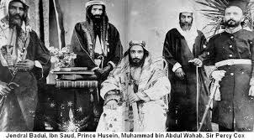

Wahhab was a barely literate preacher from Arabia who later teamed up with the tribal al-Saud's to control their territory. Like Taymiyya, Wahhab demanded a literalist meaning of the Koran. This is another reason why so many jihadist's are from Saudi Arabia (who is supposedly our ally):
see, "Wahhabi Islam", pg. 10, "No god but God", pg. 242+

"Wahhab was a very violent man whose holy warrior's eventually conquered Mecca/Medina and set to fire every book they could find, except the Koran. Referring to his followers as 'the army of God', they banned music, flowers, tobacco, alcohol and coffee. Under the penalty of death they forced men to grow beards and women were veiled and secluded."

("No god but God", pg. 244+), see also "Unwan al-Majd fi Tarikh Najd", Ibn Bishr, 1982, "Mu allafat al-Shaykh al Iman Mohammed Wahhab, "Kitab al Tawhid", vol. 3, Wahhab, "Kitab Kashf", pg. 160, "Katab al-Jihad", pg. 366

Although hardly a saint, Wahhab was adamantly against the "conversion by sword" concept:

see "Wahhabi Islam", pg. 270+

"Thanks to [ME] Saudi evangelism, Wahhab doctrine has affected the religio-political ideology of both Hamas and Islamic Jihad."
("No god but God", pg. 246), see also "How to read the Quran" law/authority

Qutb

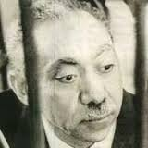
Qutb in jail

"To such heights of evil are men driven by religion." Lucretius, Greek poet
(De Rerum Natura)

"If anyone adopts the attitude of resistance then it would be obligatory on Islam to fight him until he is killed or declares his loyalty... Violent jihad is a necessary part of establishing true peace, which equals the supremacy of the Sharia." Qutb
("Milestones", p. 113, 234)

"Islam is not a 'defensive movement'. Those who follow a defensive nature of jihad lack understanding of the nature of Islam and its primary aim." Qutb
("Milestones", pg. 62)

Back in the 1960's, Egyptian theorist Sayyid Qutb pushed the process even further with his pro-sharia "Milestones". Through sharia, Qutb called for a revolt to "establish the kingdom of heaven on earth". This wasn't new since it followed the old school of Shafi'i jurisprudence from the 800's. But under Nasser's military rule his theories were not successful and he was later tortured and hanged in prison as a radical by Mubarek later on:

("No god but God", pg. 240), see also, "Political Islam: religion and politics in the Arab World", Ayubi, '91, "The Arabs: a history", Rogen

"His deranged and paranoid rants gained traction in large parts of the Islamic world and became the rocket fuel behind Islamic ideology."

("World Turned Upside Down", pg. 171)

see also, Sayyid Qutb & Islamic Activism, "Islam vs. Democracy", Shepard, "Political Theory of Islam", Mawdudi , "No god but God", pg. 238, "The Islamic Threat: myth or reality?, Esposito, '92, pg. 126-140

"[Qutb is]...a vision of the ongoing cosmic conflict between good and evil."
("Wahhabi Islam", pg. 256-7)

Totally unknown to the West, Qutb still has millions of followers everywhere:

"To the radicals, 'freedom can only exist in a Muslim theocracy--where there is no freedom. Tawhid allows only one religion; all others are not just false they are described as wicked perversions. Followers must be subdued.'"

("World turned upside down", pg. 149), see also Qutb, "In the Shade of the Quran"

"Unbelievers [in their jihad] would be the 'enemies of God.'"
("Crisis of Islam", pg. 26)

see, "Muslims: rewriting the house of Islam", Bunt, '09, pg. 218

With great irony here, if Mohammed the Prophet was living in Egypt today would he be also be tortured and hanged in prison as a radical since he supposedly wrote out the verses that Qutb followed?? Muslims have never asked this question...

bin Laden

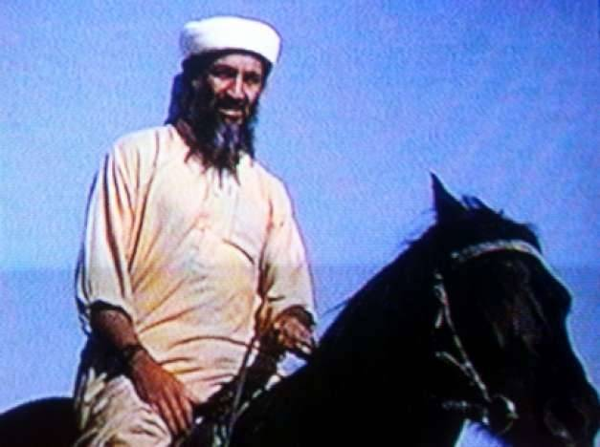

"The acme of this religion is jihad... Being killed is a great honor." bin Laden

(interview in Al Huquq, #124, May 1997), (from "Saudi Arabia", Fandy, pg. 192)

For the academic-minded the quote above is hadith and not the Koran where suicide is forbidden in several places:

"bin Laden's division of the world wasn't Wahhab but from Taymiyya and Qutb."
("Wahhabi Islam", pg. 266-75)

Bin Laden needs no introduction as the "World's Best Villain" who justified mass murder in the name of Mohammed. But he is also the most overrated. He was more of a wealthy businessman from Arabia who inherited millions from his father, was later exiled but paid others to do his political dirty work. Although he had no Muslim credentials whatsoever he would still issue fatawas to all who would listen--and millions in the ME did! Not so surprisingly they were all ignorant of their scriptures just like he was...
see, "Wahhabi Islam", pg. 255, see, "Letter to the American People", bin Laden, Nov. 24, '02

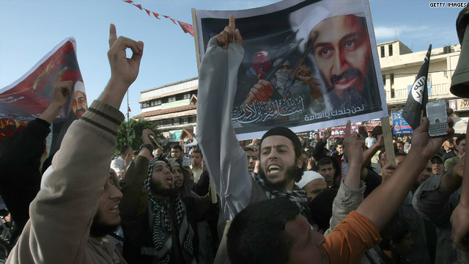

On the plus side, he did go to Afghanistan to help fight the "atheistic Communists" with the local tribesmen plus send some money to the rebels. And I'm sure at the time he would have been anti-commie Reagan's hero too. Very surprised they didn't try to meet! That could have saved America the devastating 9/11 experience plus trillions of $$$ that American's work so hard for. And any commonality here would have worked true miracles. More on 9/11 later...
see, "The Arabs", pg. 422-28

ISIS

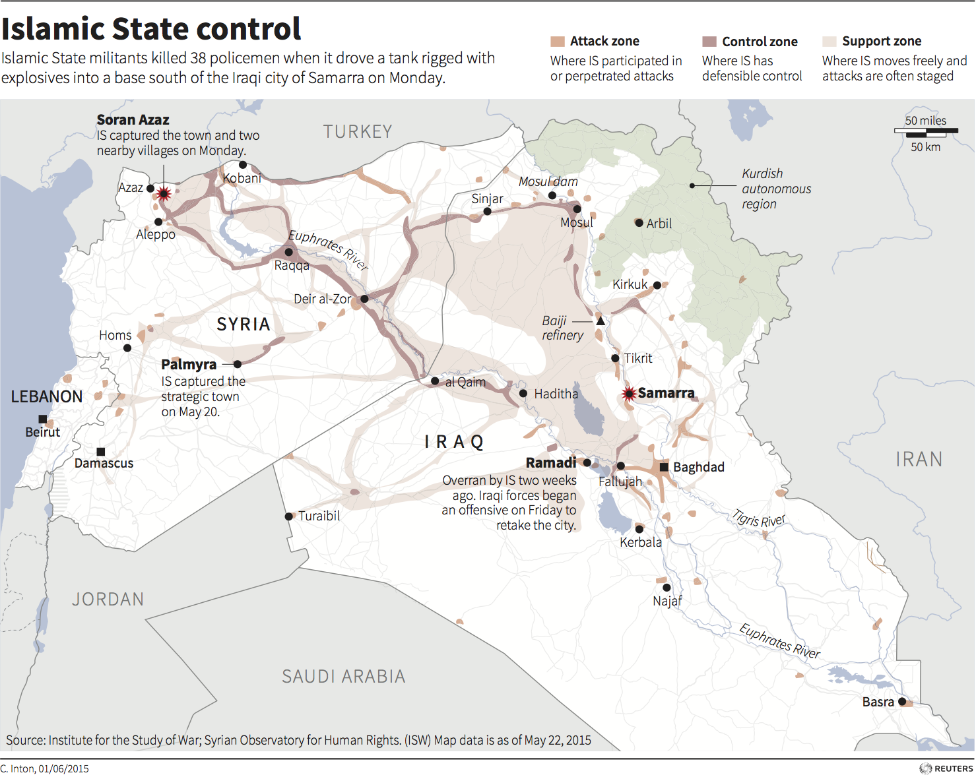

"Without an abstract ideal or external enemy boundaries are difficult to define..." A.K. Rice Institute
(AK Rice, 1965, "Learning & Leadership")

ISIS needs no intro as the world's worst villains today. Their MO is a "caliphate" somewhere in the ME. Like the Taliban, their sadistic violence and destruction are only calculated to elicit fear. Their cutting off of heads now stands as their highest horror story. But surprisingly they never invented this horror story. Instead, they got the notion from medieval Arabia circa 7th/8th c.:

"I am with you: give firmness to the Believers: I will instill terror into the hearts of the Unbelievers: smite ye above their necks [with a sword] and smite all their finger-tips off them." 8:5

It is verses like the above that draws in recruits from around the Middle East to help fight their wars. As I've touched on they don't see themselves as "extremists" in any way, shape or form. Instead they see themselves as "very devout". From their off-beat stance they think they are the victims and the not perpetrators of violence. It is the West--along with other Muslim infidels--who are making them kill the unbelievers by honoring Mohammed and their hadith. This is their twisted logic as what recently happened in Paris just a day ago:

"Fundamentalist's are anti-West."
("Crisis of Islam", pg. 23)

"Those who pervert Islam are not those who cut off the heads of disbelievers and terrorize them but those who want (Islam) to be like Mandela or Gandhi, with no killing, no fighting, no blood or striking necks... Islam is the religion of battle, of cutting heads, of shedding blood."
Islamic State cleric, Sheikh Hussein bin Mahmoud

(sourced from, "How Islamic is ISIS: not very, expert say", AP, 3/2/15)

"The Islamic State group 'appears to have adopted violent ideas first then searched books of religious interpretation to find a cover for their actions,'" said Sheikh Hamadah Nassar, a cleric in the ultraconservative Salafi movement.

("How Islamic is ISIS: not very, expert say", AP, 3/2/15)

Today ISIS are the "martyr's for Islam" (2:154) who are "fighting in the cause of Allah" (2:190) and who has "cursed and rejected them [heathens]". (2:7) The circle remains unbroken:

"Muslim's are always innocent." British Islamic extremist Anjem Choudary
(sourced from "Why we must debate the Extremist's", The Guardian, June 19, '09)

9/11


Mohammed Atta

“This is a vicious, unproked, horrible attack on innocent men, women and children. It is one of the most heinous acts in world history.” Mayor Giuliani, September 11

From the mountain of info and material decades after the 9/11 attacks somehow very little was credited to the religion itself! In other words, Americans still believed that Islam was a legitimate religion of some sort even after the devastation of 9/11. That the terrorists may have been just 'very confused people'. Yet relatively few Muslim nations condemned the attack:

“Sept. 11 can be seen as simply the latest expression of this dream... The House of Islam's war for world mastery is traditional and its quest is far from over.”
(“Islamic Imperialism”, Karsh, liner)

People know the overall 9/11 story by now but what's missing are the religious details. We know it was a terrorist act but to Muslims living in the Middle East terrorism was used almost mockingly as if it doesn't apply: 'Wink, wink', they'd smile. 'Oh terrorist?? You're kidding me...':

"...even Muslims who say they are against terrorism secretly admire and applaud 9/11."
Warreth Umar, prison chaplain
(P. Barrett, "How a Chaplain Spreads Extremism...", Wall St. J., Feb. 5, '03)

Umar was just being honest by saying that in the Middle East "terrorism" is a word that has no meaning. People that do terrorist acts against other religions or sects are instead called "extremists" but yet are still Muslim.

But without trying to grandstand here, I believe the 9/11 attack was mostly based on the Arab concept of revenge-- what the U.S. was and wasn't doing in the Middle East and Bosnia during the 1990's under Clinton. Bin Laden just connected the dots and felt the U.S. deserved a good beating for its role. I think that's all 9/11 was really about.
read, "The Great War for Civilization", Fisk

Ex-Muslims Speak Out

To further prove my point, I've included short essays from ex-Muslims who speak as witnesses against the cult of Mohammed.
________________________

"Iranian Revolution 1979", by Azam Kamguian, a political prisoner:

"In the name of Allah, 100,000 have been executed in Iran since 1979. Papers announced the names of the executed on a daily basis. There is brutal [civil] war, suppression of free-thinkers, students, women who resisted the misery of the hijab.
I was tortured by the order of the representatives of Allah and Sharia. Tortured, while verses of the Koran were played in the torture chambers...
Those not yet executed were awakened every day at dawn only to hear more rifles [shotguns] aimed at their friends... Essentially, Islam is a set of beliefs and rules against human prosperity, happiness, freedom, equality and knowledge."
(excerpted from "Leaving Islam", pg. 216)
_____

Dear redditor,
First, a brief bio:
I used to be a Muslim of over 20 years. My parents come from a country where insulting Islam is punishable by flogging, and leaving it is punishable by death. I've seen beheadings, floggings and beatings in the name of protecting the sanctity of Islam. They're not impressive in the least, and you don't want any of them to transpire a few feet away from you at an impressionable young age. I've seen the effects of Islamic fundamentalism first hand, and how extremely effective it is at stifling an entire civilization from developing into a society that favors reason, rationality and the basic, axiomatic right to express your thoughts and ideas freely... They aim to foster an environment that has its foundations firmly rooted in fear and confusion. They hope that such an environment will make for fertile ground for prejudice, bigotry and intolerance to manifest and fester.
apostasin (Reddit, Jan, 9, '15)
___________

I left because of the following reasons:
- Self contradiction in the Quran and Hadiths
- Inequality among women and men
- The issue of abrogation: it seems the God of Muslims is not all knowing
- Unforgiving God
- Mohamed never set a good example
- God who justifies murder can't be true God
- Islam encourages enmity in this world
These are the main elements which led me to leave Islam totally.
Garane Kenya, now a Christian (WikiIslam, "comments from former Muslims")

Conclusion

"Communism has been defeated; Islamism has not."
("Leaving Islam", pg. 136)

When the U.S.S.R volunteered to dump communism in 1991 I was both surprised and happy since the Cold War came to an end. They came to the conclusion on their own that its Marxist/Leninist theories were counter-productive and brought them economic ruin. So they gave up the theory; which is all Communism ever was in the first place. The world generally believes that Russia is in a better place now than before and likewise so would Islamic countries if they dumped their cult and went more secular. Some of its people want that anyway (Iran for one) and are tired of religion running their daily lives:

"Most religions offer no valid mechanism by which their core beliefs can be tested and revised. So each new generation of believers is condemned to inherit the superstitions and tribal hatreds of its predecessors."
("End of Faith", pg. 31)

"Religion is man made. Even the men who made it can't agree on what their prophets actually said or did."
("God is not Great: how religion poisons everything", Hitchens, '07, pg. 10)
One aim of this book was to paint Muslims into a corner and how their religion began as primarily a cult for invasions north. The other aim is for the West to realize that what we're dealing is a cult masquerading as a religion:

"It's time for Muslims to honestly question the principles of their faith. To admit the role of the Quran in the propagation of violence. For them to see this text for what is it: a human text, containing serious moral, historic and scientific errors."

(Warraq in interview with Josette Alia, "Islam", Nouvel Observateur, Oct. 4, '01)

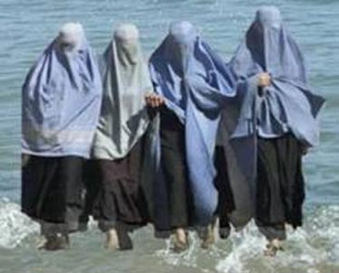
Burqa's at the beach

"There is a compelling need to free Islam from its chains as an 'identity'... There should be no reason for Islamic culture not to benefit from the development and progress of Western culture... [To a Muslim] faith is perceived as the antidote to reason. If a subject requiring faith was rationally demonstrable then faith would be irrelevant."
("Islam in Retrospect", pg. 386-391)

Can Islam be reformed?

Some liberals feel that Islam can change. I don't. For instance, the author of "Heretic" romantically believes that Muslims can be "reformed" but that "no Western liberal have been able to articulate a coherent program for reformation". But I've said that Muslim's don't like change like Christians have been able to twist around the past 400 years. Today even the Pope tries to overrule their scriptures through pragmatism:

"Today, what seems to be lacking in the core of all great world faiths is a sense of justice, compassion and knowledge."
("Journey into Islam: crisis of globalization", anthropological excursion, p. 46, Ahmed, '07

"Islam is the most rigid religion in the world. Everyone feels entitled to rule out free discussion."
("Heretic", pg. 66)

Worldwide we see that the 'cult of Mohammed' is still a rudderless ship even though most Muslims are still on board. The "caliphs" no longer have the armies behind them like in the 7th century. Their religion of conquering is behind them, which oddly Muslims in the ME still wax nostalgic over: "Oh, the good old days!" they opine..."When we were on top we ruled the then known world!" Well, that was then and this is now although they still can claim 900 million members:



"Over a billion people believe in Allah without truly knowing what Allah supposedly stands for or what he really demands of them. And the minority that do understand continue to be Moslems because they have redefined their morality and ethics to fit within the teachings of Islam, which are floridly lacking in morality. They redefine what is good and evil in order to fit their lives into what is preached by Islam, instead of examining Islam to see if it fits within the good life. Backwards thinking, imposed by a backward religion. – Professor Bertrand Russell
British philosopher, logician, mathematician, historian, and social critic

